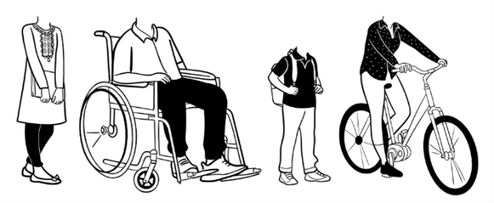
Walk Leader Training Course
Monday 26th February 2024
10am – 3pm
Manningham Mills Community Centre, Lilycroft Road, Bradford, BD9 5BD

We are delighted to invite you to attend the Walk Leader training in collaboration with Bradford District Care Trust Well Together Walks as part of our Active Travel Social Prescribing Project.
The course will cover all aspects of how to run a safe and enjoyable walk within the community; such as why should we walk and the benefits to walking, risk assessments, safety of your walkers and the qualities of a good walk leader. The session includes a demonstration walk as part of the training and before certification is given to certify you as a walk leader, you will need to complete a shadow and lead of an existing Well Together walk, which can be arranged with one of the trained volunteer walk leaders with a choice of 28 walks across the Bradford District. This list will be provided on the course day alongside a welcome pack.
To book and confirm your free place on the course, please complete the below information and return to: Jaspreet.Kullar@bradford.gov.uk.
Name:
Organisation:
Job role:
Email address:

Are you able to set up a walking group post training?
YES
NO

Will you be setting up a walking group in any of the following areas:
Central Keighley
Manningham and/or Girlington
Bradford Moor and/or Barkerend

To be completed and returned by Wednesday 21st February 2024.
Please note due to budget constraints lunch will not be provided.

