Risk Management Quality Workshop – Part 2
Wednesday 26th May (13:30 – 16:00)
Attendance – 72 Providers

Time on Zoom Recording | Activity | Lead | What the section covers + key notes
0:00 – 1:50 | Introductions | Jo Martin (Opening Minds Training and Consultancy Ltd)  T: 01423 561119  M: 07788 241546  E: jo.martin@opening-minds.org.uk | - QW Full Zoom Recording  - Presentation Slides  - Risk Management focused Quality Workshop facilitated by BCA in Partnership with Brightening Minds.
1:50 – 10:30 | The Integrated Management Performance + Quality Tool (IMPAQT) | Rachael Ross (Operations Manager at IMPAQT Care Solutions Ltd)  M: 07813 321570  E: rachael@careimpaqt.org | - IMPAQT Slides + all information  - Bradford LA Commissioners have agreed to support a ‘pilot’ of a new digital data management system known as The Integrated Management Performance + Quality Tool (IMPAQT).  - IMPAQT helps facilitate effective evidence collection, compliance + governance, improving safety and quality, reducing the burden of reporting.  - The PILOT will run from July 2021 to March 2022.  - 3 Aims:  - 1 – Support action planning, quality improvement and evidence collection with 10 Care Homes, through 1 to 1 support.  - 2 – Test and refine the IMPAQT digital systems to ensure is fit for purpose + easy to use  - 3 – Ensure the training resources and report package are accessible for Managers + Staff teams.  - The first version of the systems is for Residential Care and Nursing Homes, with versions for Home Care, Extra Care Housing coming next (around September)  - Please fill out the EOI form below if you would like to take part, please email rachael@careimpaqt.org by Friday June 18th, at 5pm.  - Expressions of Interest Form (EOI)
10:30 – 11:30 | Last Quality Workshop recap | Jo Martin | - Our last QW was really successful with over 120 Providers joining.  - It was focused on CQC, and we had a CQC representative join us.  - If you would like the Resource pack from this event, please email@bradfordcareassociation.org with you request.  - If you would like the CQC answers to the questions from the QW please email admin@bradfordcareassociation.org with your request.
11:30 – 14:00 | Today’s Session Introduction | Jo Martin | - What to expect from today’s session: Sharing ideas, thoughts and experiences around managing risk, to help us complete our provider information return (PIR).  - TOP TIP – use the workshops to start evidencing down what you do to make it easier when asked to complete your PIR.
14:00 – 23:00 | Back to basics – Managing Risks | Jo Martin | - Talking through ‘back to basics’ of managing risks (Identify hazards, assess the risks, control the risks, record your findings and review the controls)  - Sensible Risk Management in Care Settings  - What do CQC say about managing risks
23:00 – 28:00 | Slido |  | - Providers were asked ‘What evidence do you have of how you manage organisational risks?’ (Appendix 1 – answers)
28:00 – 38:00 | Dynamic Risk Assessments | Jo Martin | - A dynamic risk assessment is the process of continually observing and analysing risks and hazards in a changing or high-risk environment. This allows workers to quickly identify risks and manage them effectively.  - Formal Risk Assessments are prepared in advance and recorded and monitored on a regular basis.
38:00 – 42:00 | Slido |  | - Providers were asked ‘What organisational risks have you had to manage in the last 6 months?’ (Appendix 2 – answers)
42:00 - 1:11:00 | PIR and Risk Management – BREAKOUT ROOMS | Clare Flynn (Registered Manager at Brightening Lives Ltd)  M: 07444 458641  T: 01423 561119  E: clare.flynn@brighteninglives.co.uk | - PIR talks about 2 areas (Staffing + IPC) Need 500 words for each question.  - Exercise around this going into breakout rooms think about 2.15 question in your PIR – ‘How do you ensure your staffing is sufficient in numbers and quality to meet all the needs of those you care for?’  - Start to ask yourself:  - 1. What are you concerns around staffing numbers and quality/skill mix?  - 2. Who are you concerned about and why?  - 3. What do you already have in place that helps you manage these concerns?  - 4. What other things do you need to do?
1:11:00 – 1:28:00 | Feedback from the Breakout rooms |  | - Feedback Group 1:  - Concerned around the number of staff they have lost for a number of reasons, so hired more staff however these new set off staff didn’t have the organisational knowledge or the experience of knowing what care and needs some residents need (knowing their history). To try and manage these concerns they would try and buddy staff up (experienced staff with non-experienced), shadowing, mentoring, training, recruitment process change, and changes to the mentoring processes.  - Feedback Group 2:  - Concerns around managing when occupancy levels went down (staffing models) and the image of Social Care (Social Care being blamed for Covid being in Care Homes). Concerns around the fear about coming into the sector. Tried to manage these concerns with the use of technology and videos, this would help staff feel more comfortable + safe working in the sector. Concerns around getting back to managing within the new norm and managing staff absences + sickness quickly and efficiently.  - Feedback Group 3:  - Main concerns around recruitment, retention and then making sure you have the right mix of different languages, cultural backgrounds gender etc. Recruitment (getting the people we want in our organisation) around this can be a big challenge. Concerned around the safety of the service and safety of who you’re looking after in your service. It’s also around the well-being of staff working and ensuring that they have no extra pressure because of other staff not being the right person for the job. To prevent this Providers spoke about buddying staff up, digital training platforms (Bridge + Altura), care management systems, ensuring that residents are involved in the training so staff can get lots of great feedback to make sure they are delivering their service safely, efficiently and correctly whilst making relationships along the way. Providers also stated that some of them have lunchtime meetings (to talk about nutrition + nutrition champions), have a manager give a 1 hour meeting every day to senior managers to discuss exactly what is going on in the day. Also, the use of useful comms such as WhatsApp etc.  - Feedback Group 4:  - Concerns around recruitment + retention and making sure the correct staff for the job are hired (also making sure it’s a continual process). Also making sure the staff that are hired know what they are going into (expectation of the role compared to what it actually brings). Concerns around burnout out staff due to it being the hardest year with the pandemic (anxiety + fear). All helped by managing the risks, managing the staff correctly, induction the new staff correctly (mentoring + training), having a pool of bank staff. Also thinking about value-based recruitment and thinking about making sure you’re hiring the correct people for the job role and for the people they are caring for.
1:28:00 – 1:38:00  1:38:00 – 1:44:00 | Skills House Presentation - | Rachel Broadhead (Skills House + Projects Officer at Skill House)  W: www.skillshouse.co.uk  M: 07582100967  E: rachel.broadhead@bradford.gov.uk | - Presentation Slides  - Up skilling people who are interested in working in the Care Sector (from higher education)  - Use a system approach which is inclusive recruitment using the Skill House Model  - Explains the different pathways that candidate will go through (Qualifications, RAG rated, training, courses etc) before they then join your place of work and work for you.  - Job + Apprenticeship Template  - Skills House have really good recommendations – “Really useful and super easy to get the right candidate for your job role”
1:38:00 – 1:44:00 | 5 MIN TEA BREAK |  | - 5 MIN TEA BREAK
1:44:00 – 1:50:00 | Looking into Risk Management + PIR Questions | Clare Flynn | - We need to ensure that whilst we are continuing with Risk Management that we are also empowering people, making people we are providing for feel safe, comfortable and happy that they are living the life how they want to be (making sure we don’t lose focus on this due to the Pandemic).  - This and the next section will help you to answer C2 Question in PIR: How does the service support people to express their views and be actively involved in making decisions about their care, treatment and support as far as possible?  - Video (Person centred approaches in the Care Sector)
1:50:00 - 2:14:00 | Receiving Support Representative | Rachel Moody (Director at Opening Minds – User led organisation) | - Hearing from Rachel Moody (Director at Opening Minds – User led organisation) who helps out with a lot of the training and accessible information they produce.  - Rachel is autistic and received 3 hours of support a week from a local care company (support is for things like food shopping, phone calls and appointments – changed slightly during the pandemic).  - She believes it is important that she is involved in decisions about her support to ensure she gets the best possible support needed (had experience in the past where she has not got the best support, she needed due to not listening to her and her decisions, this made her feel very worn out).  - Example of Positive Risk Taking in Rachels eyes: One support worker loved to go climbing at a climbing wall, this carried many risks of course. Rachel was able to go, and she enjoyed the activity. Another example is that one of her support workers is currently helping her plan a holiday. She feels like they have really listened to her when she has spoken about what she wants to do and what concerns she has. She feels extremely happy that she is able to do what she wants to do safely with support + they have not just dismissed it and that they are finding away around her concerns.  - Rachel stated that due to the pandemic we are all currently under some restriction that we have to follow such as PPE and most people have got really fed up with it. However, she stated for many disabled people, they have restrictions placed upon them their whole life (their norm). During the pandemic everyone has started to get fed up with the restrictions however know why they need to follow them to ensure they stay safe. For many disabled people, this is different as they don’t understand why they need to follow some restrictions, creating anger.  - As a Provider what can you do to support people positively? Rachel believes that their needs to be discussion with the person you’re caring for, creating a really good risk management profile. She also believes it is important that the carer needs to understand the difference between risks and actual risks (giving the person you’re caring for the benefit of the doubt and letting them try new things).  - Be creative when evidencing the support, you give (put everything in care plans)
2:14:00 – 2:22:00 | Summary of exceptional outcomes | Jo Martin | - Summery pulled from CQC guidance around KLOE (good + outstanding organisation characteristics – can be found on the website)  - TOP TIP – website is really good at helping you describe your evidence using good language, so it comes across clearly.  - TOP TIP – Importance of continuously reviews on risk assessments (things change change).  - TOP TIP – When you do something as minor as dealing with late staff absence, this is all dynamic risk assessment as you’re responding quickly to a problem, make sure you evidence everything and use the 5 points that the Health + Safety executive state (earlier on in the workshop).
2:22:00 – 2:24:00 | Positive Risk Management | Jo Martin | - Any questions for CQC that you may have for CQC please email admin@bradfordcareassociation.org and we will get the answers for you.
2:24:00 – 2:28:00 | SLIDO |  | - How have you found the Risk Management Quality Workshop today? (Appendix 3 - answers)
2:28:00 | NEXT QUALITY WORKSHOP |  | - BCA are creating a PIR Guidance Workbook to help simplify and break down the questions for you making it easier to complete (should be ready for next Quality Workshop – 7th July)  - NEXT QUALITY WORKSHOP: Infection Preventation and Control focused– Wednesday 7th July (13:30 – 16:00) Agenda + Free tickets to follow)  - CQC will be joining this session.

Please see appendix on next few pages:

Appendix 1

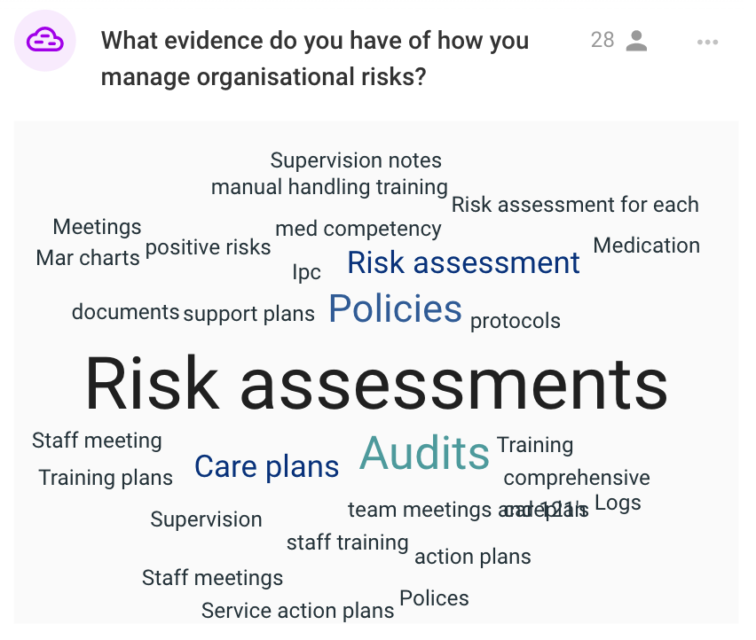

Appendix 2

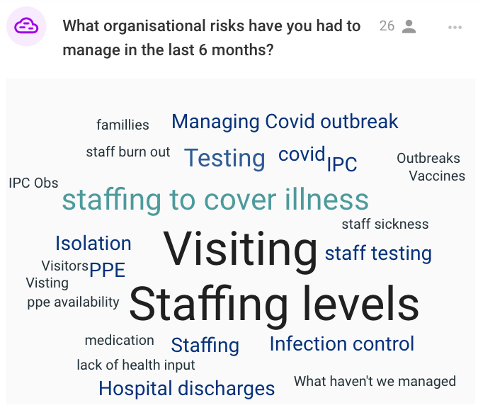

Appendix 3

