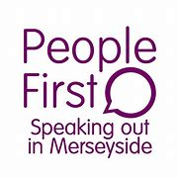
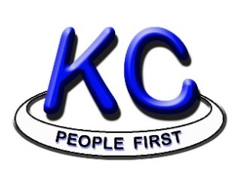
People First Merseyside
would like to Invite you to
Cancer Red Flag and Lung Health Roadshow
On
Friday 28th May 2021
At
Central Hall, Alice Street, Keighley. BD21 3JD
Either
10:00am-12:00pm or 1:00pm-3:00pm
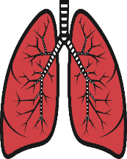

Choose which session* you would like to attend and email us to confirm your place
Hanna.bennett@peoplefirstkc.com
Anita.gray@peoplefirstkc.com
Anne.Hesse@peoplefirstkc.com
Morning Session 10:00am – 12:00pm | Afternoon session 1:00pm-3:00pm
Yes / No | Yes / No
*please edit which session you would lik to attend so we can count numbers.
If you have any accessability needs, please lets us know so we can make reasonable adjustments:

