Agenda 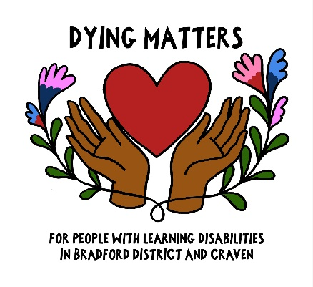
Positive Conversations about Death & Dying with People with Learning Disabilities
9.30 Arrival and drinks
10.00 Natalie & Carol Beardmore - Why do we need conversations about death & dying?
10.15 – The Big Soup - Life Cycle
10.50 Amy Russell & Christopher Porter - “Planning for a health emergency” research project
11.00 Katie Peacock - ‘Farewell to Mumma’ – How Gareth’s support team enabled him to be at the centre of his Mum’s funeral
Quick coffee break and stalls

11.40 2 workshops –
1) Katie Peacock - Board game & conversation starters

2) Dorcas Lambert, BTHFT - What’s important when thinking about future planning (ReSPECT)

  - – 1.00 pm – Lunch & stalls

1.00pm People First Merseyside - The DAVD project
1.30 - Carl Challinor, BDCFT library - Resources talk
1.35 – Nadia Clarke talks about how she remembers her twin brother Liam

1.40 2 workshops -
1) Marilou Armada, End of Life educator talks about the support available to care providers working with people with learning disabilities

2) Bradford People First - Making memory box’s

2.15 pm – Keighley People First & Dr Mike Hughes Question and Answer session

2.35 pm Slater & Gordon Solicitors - Wills & finances

2.55 Carol & Natalie conclude the day & think about Next Steps (Share workshops and drop-in group)
Stalls
Library resources stall
Hospices stall
Childrens team, BDCFT
Healthwatch
Alzheimer’s Society
KPF

3/3.15 pm Finish

