Care Home Friends and Neighbours: Intergenerational Linking Project
Dear Colleague,
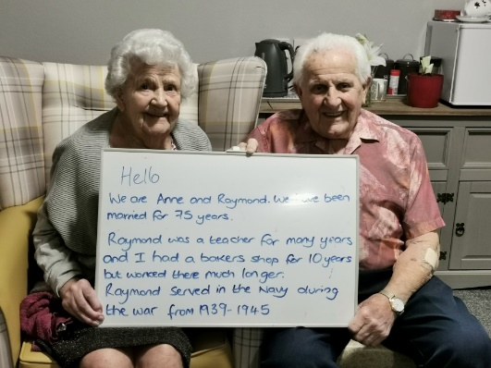
We are writing to invite you to be involved in the exciting Bradford Intergenerational Linking project. The project will link your care home with a local school or youth organisation so that older people can share stories and develop meaningful relationships with children and young people.
The Intergenerational Linking programme will be a virtual programme initially where children and older people in care homes will connect by exchanging messages and activity outcomes. We are clear that it must be manageable for all involved. The Linking Network will provide virtual training for youth leaders, teachers and care home staff to equip them to lead the project. We will also provide a range of activities and resources which are tailored to the current context along with ongoing guidance to support Intergenerational Linking.
Further information is attached.
In order to support the intergenerational link, TLN are pleased to be able to offer some funding for resources and cover costs.
If you would like to express an interest in taking part in the Intergenerational Linking project, please complete the form attached and we will get in touch to discuss suitable links. If you have any questions, please do not hesitate to contact us.
Kind regards,
Amy Lock – amy.lock@thelinkingnetwork.org.uk
Please return by email
We would like to express an interest in taking part in Intergenerational Linking in 2021-2022.

Name of care home:

Name of manager:

Name of person to contact to discuss the link:

Email of person to contact to discuss the link:

Number of beds:

Name of school/ youth organisation if a link already exists:
We can discuss start dates that work for schools/ youth organisation and care homes.
The programme will be manageable for all involved with resources and support provided.

Further information:
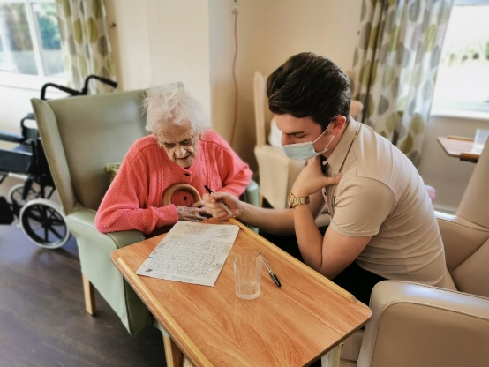
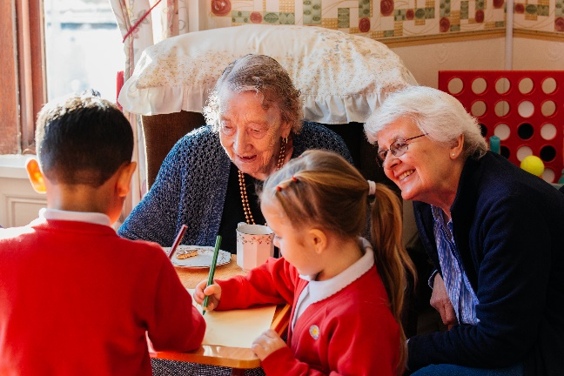
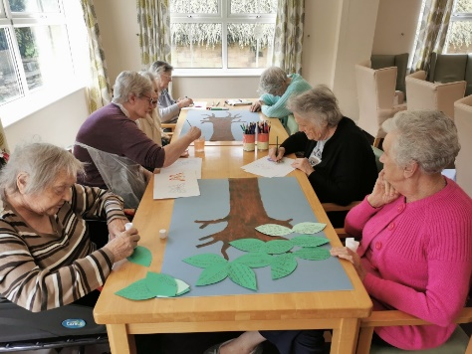
This project aims to connect care homes for older people with a local school or youth organisation so that both younger and older people can engage together in a range of activities. As well as meaningful connections between generations, the project encourages young and older people to take ownership of the link, making decisions about the project and ensuring that all voices are hear. The project is being funded through the #iwill fund, a joint investment between The National Lottery Community Fund and the Department of Digital, Culture, Media & Sport.
“The project was good because I was helping people who were older than me and it must make them feel happy too.” – Labiba, Year 5
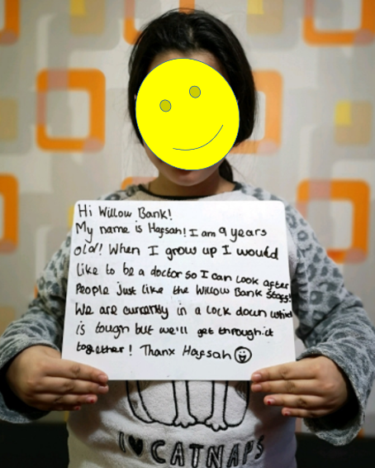
“The project made me feel joyful because we were linking with other people older than us people and doing fun activities with them.” – Husnain, Year 5

“Our ladies and gents residents really enjoyed completing the wordsearches and they were humbled that the pupils had gone to so much trouble and put so much through and time into creating them.” – Care home activity coordinator.

This project is part of Care Home Friends and Neighbours: Intergenerational Linking – an initiative linking young people from schools and youth organisations with older people living in care homes across England. The project is funded through the #iwill Fund. The National Lottery Community Fund and the Department of Digital, Culture, Media & Sport are each investing £25 million seed funding to create the #iwill Fund. The Dunhill Medical Trust is acting as a match funder and awarding grants on behalf of the #iwill Fund.

