Quality Assurance Quality Workshop – Part 5
‘Winter is coming, but Social Care will carry on…’
Wednesday 17th Nov (13:30 – 16:00)
Attendance – 55 Providers

BCA’s AGM was prior to this Workshop, so if you are watching the Zoom Recording, please look at the time on the table below.

Time on Zoom Recording | Activity | Lead | Notes
1:01:00 – 1:03:00 | Introductions | Jo Martin  Trainer at Brightening Lives Ltd  www.brighteninglives.co.uk | - QW Full Zoom Recording  - Presentation Slides  - Quality Workshop facilitated by BCA in Partnership with Brightening Minds. This session is about Winter planning and offers advice, guidance, and resources to help you and your organisation be prepared for the Winter period.
1:03:00 – 1:09:00 | Winter pressures + celebrations for Adult Social Care | Iain MacBeath  (Strategic Director, Health and Wellbeing) | - Adult Social Care + NHS face a very difficult Winter, and both are already really under pressure. The Care Sector is in a fragile state, due to the current labour market. The Care Sector is low pay and high skills area of work. The workforce is exhausted and the is a continued uphill battle to retain and recruit staff in the sector.  - Major pressure on the sector to manage people’s ill health at home, rather than phone 999, discharge more poorly patients quicker into Care homes or those with higher levels of need (fortunately there is a pot of money from the CCG that can be drawn down on the discharge – pay a decent fee level for this). There is no doubt that organisations will experience staff shortages due to the winter period  - Reminder to note that with all these issues the sector may face, within that are hardworking staff that always got the extra mile to provide support and care, making families and the people they support very proud and happy. It’s also important to celebrate the last year:  - Lowest risks for staff mandatory vaccinations in the region – Bradford Airedale Hospital aren’t in the top 100. This just shows that the system all working together is paying off.  - Very little Care Business closures  - Huge thankyou to everyone within Adult Social Care and the help of everyone within it!
1:09:00 – 1:10:30 | Slido Poll | Jo Martin | - Providers were asked: Do you feel supported by Bradford Council and Bradford Care Association as a partner to meet the care and support needs of Bradford citizens. (Appendix 1)
1:10:30 – 1:57:30 | CQC Q+A | Lorna Knowles – Inspection Manager, CQC | - The BCA asked Providers what current questions you have that we can ask local inspectors to be able to understand the current landscape giving the critical current context.  - BCA are currently in the process of receiving the answers to the questions in written form. These will be out next week.  - If you would like to watch the Zoom recording, please go to the time stated (1:10:30 1:57:30 and watch the CQC Q+A)  - The questions asked were:  - What consideration are CQC inspectors giving this when inspecting services?  - How is this being viewed by CQC inspectors?  - What consideration is the CQC giving to demoralised and exhausted providers in inspections?  - How are CQC inspectors responding in inspections to this type of feedback from staff members?  - What are CQC wanting to see in place to manage this staffing crisis to be seen as compliant with the regulations in these unprecedented times?  - What impact is this national knowledge having on inspection outcomes nationally and local inspection outcomes in the Bradford area?  - In the face of staff shortages what actions do the CQC regard as acceptable to maintain compliance to be able to offer continuity of support in an alternative way? i.e. temporary adjustments in service delivery based on people’s priority of need - reducing levels of community calls delivered/reduction to planned care packages in the event of contingency plans needing to be activated?  - When maintaining the safety levels of a service is compromised i.e., challenged by unplanned absence, what steps / mitigation do the CQC expect providers to take? i.e., Reduce the capacity of the service (beds available), creative use of existing resources i.e., no nurse physically available yet use nurse to be on call  - Please describe how you will do this in the Bradford area and what ‘proportionate & on its own merits’ means in this CQC statement in practice.
1:57:30 – 2:12:00 | Introduction to Winter Planning Self-Assessment Toolkit | Liam O’Neill – Care Sector Liaison Officer, Covid-19 Support Team  Emery Nanje-Ngoe – Care Sector Liaison Assistant – Covid-19 Support Team | - Covid-19 support team, with the help of BCA, created a document that shows that organisations need to consider to their own self-assessment to inform a business continuity plan over the winter period.  - This document will help you to be able to demonstrate to CQC what you’re doing and put a load of resources in one place, along with checklists. This will help you identify areas that you may need to work on.  - For the Winter Planning Self Audit Tool CLICK HERE  - For the Winter Audit Tool Checklist CLICK HERE  - If you have any further suggestions or changes to the checklists, please email admin@bradfordcareassociation.org
2:12:00 – 2:33:00 | In Breakout Rooms – See below for discussions | - | - In Breakout Rooms – See below for discussions
2:33:00 – 2:44:00 | Breakout Room exercise –Winter Planning Self-Assessment Toolkit | Jo Martin | Breakout Room Discussions:  - If the toolkit will be useful for business continuity plans.  - Providers were asked do you understand the full range of challenges they have to be thinking about.  - How do you think this toolkit will help you to manage risks and the risk of threat to your ongoing compliance?  - Do you think it will create a clear action plan to share with your inspectors, is there anything else that needs to be added to the toolkit?  - Are there any resources that can be shared and can be included in the toolkit.  Breakout Room 1 Feedback:  - Very useful prompts to ensure you have everything in place that you need to have.  - CQC have been looking more into mental health so the group discussed how useful the mental health section was and how this could demonstrate good practise to CQC.  - Addition to the checklist – One provider suggested a vaccination status for Domiciliary Care  - Addition to the checklist – Is there any apps that could be downloaded onto people phones with the MET office / weather warnings from the Council.  Breakout Room 2 Feedback:  - Really useful prompts to then start creating your business continuity plan.  - Deployment of staff in the hard-to-reach areas – snow last year and how this created challenges to Home Care. Gritting not being done in certain areas.  - Medication + timely visits  - Addition to the checklist – Create links with the CQC requirements  Breakout Room 3 Feedback:  - Really useful document – even for those providers that have contingency plans in place, however this could benefit them by using it for further prompts  - Some Providers felt this could just be another job they have to do, even when they feel overwhelmed already – leads onto mental health.  - One Provider has SOS bags (with list of resident’s names, fire blankets, contingency plans etc) spread around their Care Home, so in the case of an emergency they can grab a bag  Breakout Room 4 Feedback:  - Addition to the checklist – Make sure there is a ‘N/A’ in there, so when completing the toolkit, it doesn’t look like you have not done it, it’s just that it is not applicable in your service.  - Addition to the checklist – Show where it is evidence instead of just ticking a box.  - Addition to the checklist – Checklist to show and ensure that you’re to communicating with families etc
2:44:00 – 2:52:00 | TEA BREAK | - | TEA BREAK
2:52:00 – 3:06:30 | Support with Workforce | Matthew Clarke – Care Sector Liaison Officer, Covid-19 Support Team | Small team working on workforce consisting of 4 people. They are working on a workforce pathway to get people into the Care Sector. There was originally a small idea, however the team has managed to build on this, and it now consists of 5 key areas:  - Set the infrastructure with Skills House + Colleges (Had conversations with Keighley college, Shipley College and Bradford College – all on board). Created a job seekers pathway which covers all areas of what positions people make be in (loads of skills and all the certificates or nothing at all). Skills House would be the first point of call, having conversations with the people finding out what support they need to get into Social Care.  - Social Care Recruitment Campaign – Started to get the ball moving, but it will be a 2 phased campaign. The first phased should be being noticed now in your day-to-day life, and the second phase will follow (hopefully before Christmas) when there is a larger campaign.  - Covid Support Worker Redeployment – Value based recruitment  - Grassroots Community Recruitment – Skills House are linking up with Community Centres across Bradford. These will re-establish these partnerships encouraging more people to start working in Adult Social Care.  - Social Care Academy – New idea and working progress.  - Please see top of page for more information regarding the 5 key areas (more details and information).
3:06:30 - 3:12:00 | Skills for Care | Ailsa Benn  ailsa.benn@skillsforcare.org.uk  Locality Manager - (Yorkshire and Humber/NE)  Skills for Care | Workforce Wellbeing Resource Finder:  - Skills for Care has launched an easy tool to help our social care workforce find trusted resources to support their own or others wellbeing. Types of resources available through the finder:  - Self-help and support for others  - Needing someone to talk with confidentially  - Support with mental health  (For more info about above - www.skillsforcare.org.uk/wellbeing)  - NEW: bite size wellbeing guide for managers:  Take a look at our new bite size wellbeing guide, based on the New Economics Foundation Five Ways to Wellbeing.  Building Resilience – New Bite Size Guides:  - Resilience is the ability to cope under pressure and recover from difficulties. Skills for Care has developed two bite size guides to provide you with some quick support on how to build your own resilience (Coping in the moment + What is resilience and why does it matter?) Find out more  Learn from others  - To expand their wellbeing support, they have launched their ‘learn from others’ area of the website where you’ll find good practice stories, and practical tips and ideas from a diverse range of social care providers. The page will be regularly updated with new stories, but right now you can find:  - Using mindfulness to support mental wellbeing  - Words of wisdom to encourage you to look after your wellbeing  - Compassionate and human approach to leadership  - Created ‘staff bubbles’ to protect peer-to-peer support  View the learn from others stories  New webinar recording: Contingency planning and winter pressures: Protecting your service  - Skills for Care has updated our earlier webinar recording and bite size resources. It includes 20-minutes of specially recorded new content including interviews with an Outstanding rated care home and an Outstanding rated homecare service explaining how they protect themselves from staffing challenges and how they have applied learning from last year. The updated recording is complemented by refreshed bite size resources:  - Practical ways for your Contingency Plan to succeed  - Contingency Planning - What to include  - Contingency Planning FAQs  You can access these via: https://bit.ly/2ZS3ywS
3:12:00 – 3:22:30 | New version of BCA PIR Workbooks + Benefits | Louise Bestwick – CEO, Bradford Care Association | NEW FORMAT / VERSION AVAILABLE (See below)  BCA developed some PIR Workbook’s to support you to complete your PIR. You will be able to use it as a master document that you can keep up to date.  The benefits of the PIR Workbook includes:  - Support you to delegate tasks/questions to other individuals  - Keep an up-to-date live document  - All your questions and answers are in one place  - Be able to copy and paste your answers into the actual PIR  - Be able to start you PIR early  - Have an on-going record that you can refer to each year  - Links to the relevant KLOE’s to help you to identify them clearly in your answers  - Links to the good and outstanding characterises to help you to identify them clearly in your answer  - Brings the team together to help complete it (shares the workload)  Providers found these workbooks extremely useful however some Providers had some concerns around the format as it was difficult to print out for those wanting to complete it that way. Since then, BCA have taken on this feedback and created a new version that is easier for Providers to use, when printing or completing on the excel document. It’s much easier to follow and will be very useful to help you complete your PIR.  There have also been some additional parts to the Workbook, making it even easier when you get given your PIR and must start completing it.  For more information on changes or if you would like the new version of the PIR Workbooks please email admin@bradfordcareassociation.org
3:22:30 | HALSA | Karen Thornton  karenthornton@care247.ltd.uk  Associate Director Care 24-7 Ltd | There is a Self-Care Wellbeing Session being held on 24/11/21 (3pm – 4pm)  - Live and interactive session, provided for you as a Registered Manager working in Bradford District and Craven, where you will learn some simple self-care techniques through breathwork, movement, stretching and relaxation. This session is specifically designed for managers to help demonstrate the importance of self-care so that you can build resilience against external stress factors and work to optimum levels within demanding environments. It will also demonstrate how to lead by example so that you can also encourage team members to take part in daily self-care routines which will support their physical and mental wellbeing.  Join on your computer or mobile app  Click here to join the meeting  Instructions for the Self care Wellbeing Session  If possible, please use a hard-backed chair and wear comfortable clothing. You only need a small space around you to stretch your arms out as all of the exercises demonstrated are chair based. Please also have water available as the session can make you thirsty.  Leading Mental Wellbeing Together Sessions:  - Thursday 18th November, 13:00 – 15:00  - Tuesday 7th December, 10:00 – 12:00  - Thursday 9th December, 13:00 – 15:00  - Wednesday 15th December, 13:00 – 15:00  - Thursday 16th December, 10:00 – 12:00  This two-hour interactive facilitated webinar explores the concept of mental wellbeing within the context of leadership and the ongoing response to the Covid-19 pandemic. The course provides leaders with information and guidance on managing wellbeing in the workplace, using up-to-date research evidence and best practice. Topics covered during the session include recognising the signs of poor mental wellbeing, self-care, leading through adversity, as well as practical wellbeing tools which can be used with colleagues.  To book yourself onto the Leading Mental Wellbeing Together Webinar, please email: bdcccg.wyh.mentalwellbeinghub@nhs.net  For more information visit Living Well Training – Training for a healthy mind.
3:28:00 - | Evaluation Slido Poll’s | Jo Martin | Providers were asked:  - Do you feel more prepared in the topics you need to consider, to effectively plan sustainable service delivery over the winter period? (Appendix 2)  - How have you found the Winter planning workshop today? (Appendix 3)
 | THANK YOU, NEXT QUALITY WORKSHOP DATES, | Clare Flynn | Thank You for all your hard work this year and we hope you have a lovely Christmas and New Years.  Next Quality Workshop will take place next year - Agenda + Tickets to follow.

Appendix below:

Appendix 1

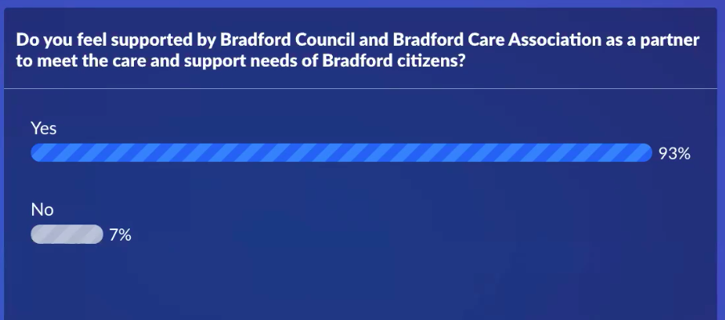

Appendix 2

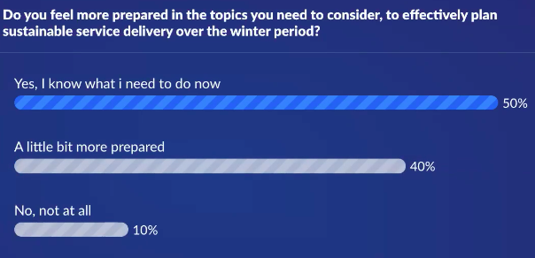

Appendix 3

