Cost of living campaign: looking after your mental wellbeing during difficult times – internal communications toolkit
Background
In lead up to World Mental Health Day (10 October), Bradford District and Craven Health and Care Partnership is taking a partnership-led approach on delivering a campaign on how individuals can look after their mental wellbeing during difficult times. The focus of this campaign fits in with the system-wide cost of living campaign over the coming months, and October will be themed around mental health.
There will be five information stalls taking place across the district, these will be at:
- Monday 10 October, from 10.30am to 2.30pm, The Broadway, Bradford (near the old Debenhams), BD1 1JR
- Monday 10 October, from 10.30am to 2.30pm, Bradford Teaching Hospitals NHS Foundation Trust (main hospital concourse), BD9 6RJ
- Wednesday 12 October, from 10.30am to 2.30pm, Keighley Market Hall (front entrance), Keighley, BD21 3PT
- Thursday 13 October, from 10.30am to 2.30pm, Airedale NHS Foundation Trust (top landing in Zone C), Keighley, BD20 6TD
- Friday 14 October, from 10.30am to 12.30pm, Airedale Shopping Centre (near Costa), Keighley, BD21 3QQ.
Purpose of the stalls will be to make people aware of the support they can access through the cost of living crisis, this includes support for their mental wellbeing. Colleagues from the voluntary and community sector, as well as health and care will be staffing the stalls.
Included in the toolkit
- Generic copy – for newsletters and websites
- A4 poster
- Screensavers / TV screens
- Mental wellbeing support during day and night support
- Social media copy:
- promoting the information stalls week commencing 10 October

- promoting mental wellbeing support for daytime and night across Bradford District and Craven
Generic copy – for newsletters and websites
This World Mental Health Day (Monday 10 October), the voluntary and community sector, as well as health and care across the district will be working together to encourage individuals to access support for their mental wellbeing during these difficult times.
The surge in prices over recent months has created a cost of living crisis that is exacerbating insecurity and harming people’s mental health. We know this is going to have a devasting impact for people up and down the country and our most vulnerable communities in the district who are already having to make tough decisions. It’s important that people get the support they need for their mental health as well as the cost of living.
During week commencing 10 October there will be five information stalls in the following locations:
- Monday 10 October, from 10.30am to 2.30pm, The Broadway, Bradford (near the old Debenhams), BD1 1JR
- Monday 10 October, from 10.30am to 2.30pm, Bradford Teaching Hospitals NHS Foundation Trust (main hospital concourse), BD9 6RJ
- Wednesday 12 October, from 10.30am to 2.30pm, Keighley Market Hall (front entrance), Keighley, BD21 3PT
- Thursday 13 October, from 10.30am to 2.30pm, Airedale NHS Foundation Trust (top landing in Zone C), Keighley, BD20 6TD
- Friday 14 October, from 10.30am to 12.30pm, Airedale Shopping Centre (near Costa), Keighley, BD21 3QQ.
These stalls are open to everyone, and you don’t need to book onto these. We would encourage people to attend, as you’ll be able to find out where you can get support with your mental wellbeing as well as the cost of living.
If you’d like further information on how you can get support for your mental wellbeing, please visit www.healthyminds.services
To find out how you can get support with the cost of living, please visit:
- Bradford Council (website will go live on Monday 10 October)
- Craven Council

A4 poster
Help to promote the information stalls taking place week commencing 10 October by displaying the A4 poster in your buildings and share amongst your networks.
**Please note there are two sets of flyers one with two QR codes (to Bradford Council website and the other to Craven Council website on what support is available around cost of living and how to access support with their mental health), second without any QR codes
Poster with QR codes Poster without QR codes
Screen savers
Promoting the information stalls
You can promote the information stalls taking place week commencing 10 October by adding the following screen saver:
**Please note there are two sets of flyers one with two QR codes (to Bradford Council website and the other to Craven Council website on what support is available around cost of living and how to access support with their mental health), second without any QR codes
Screen saver with QR codes Screen saver without QR codes

Mental wellbeing support during the day and night A5 flyer
Information on how to access support for your mental wellbeing across Bradford District and Craven during the day and night:
Social media (Facebook, Twitter, and Instagram) - promoting the information stalls week commencing 10 October
Facebook
Post one | Post two
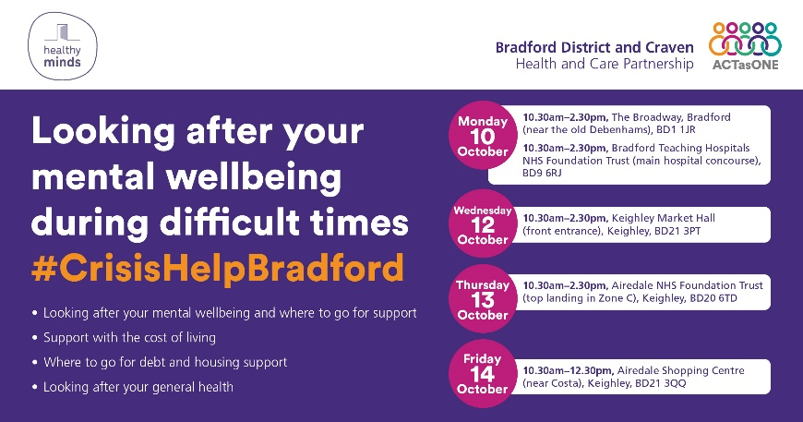 | 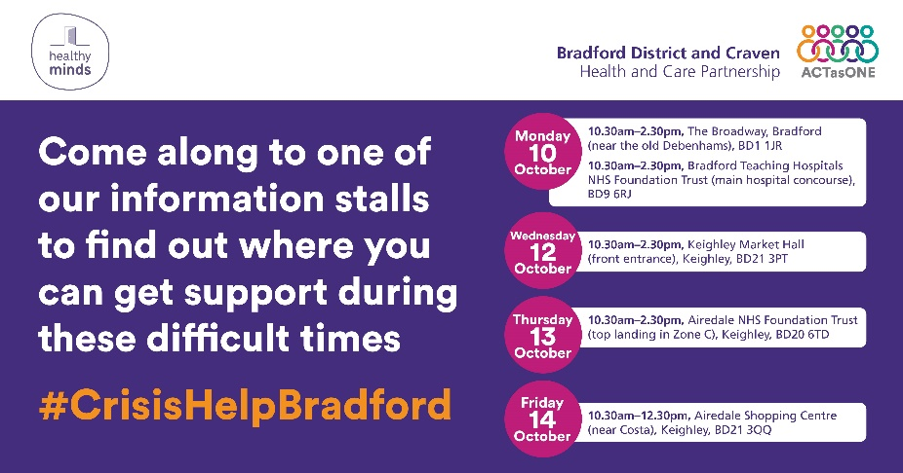
During these difficult times, it’s important that you look after your #MentalHealth – attend one of the information stalls taking place in the district and see what support you can access for your mental health, as well as the cost of living. For information and advice to help with your emotional wellbeing, visit www.healthyminds.services #WorldMentalHealthDay #CrisisHelpBradford  ALT: Looking after your mental wellbeing during difficult times #CrisisHelpBradford Information stalls will be taking place on Monday 10 October at Broadway from 10.30am to 2.30pm, Monday 10 October at Bradford Teaching Hospitals NHS Foundation Trust from 10.30am to 2.30pm, Wednesday 12 October at Keighley Market Hall from 10.30am to 2.30pm, Thursday 13 October at Airedale NHS Foundation Trust from 10.30am to 2.30pm, Friday 14 October at Airedale Shopping Centre from 10.30am to 12.30pm. Stalls will provide information on looking after your mental wellbeing and where to go for support, support with the cost of living, where to go for debt and housing support, and looking after your general health | During these difficult times, it’s important that you look after your #MentalHealth – attend one of the information stalls taking place in the district and see what support you can access for your mental health, as well as the cost of living. For information and advice to help with your emotional wellbeing, visit www.healthyminds.services #WorldMentalHealthDay #CrisisHelpBradford  ALT: Come along to one of our information stalls to find out where you can get support during these difficult times #CrisisHelpBradford Information stalls will take place on Monday 10 October at Broadway from 10.30am to 2.30pm, Monday 10 October at Bradford Teaching Hospitals NHS Foundation Trust from 10.30am to 2.30pm, Wednesday 12 October at Keighley Market Hall from 10.30am to 2.30pm, Thursday 13 October at Airedale NHS Foundation Trust from 10.30am to 2.30pm, Friday 14 October at Airedale Shopping Centre from 10.30am to 12.30pm.
Twitter
Post one | Post two
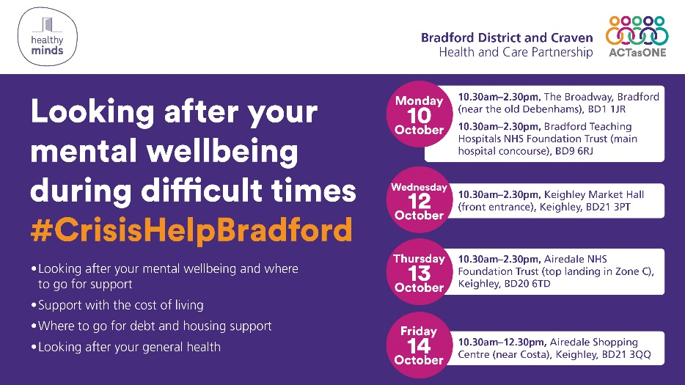 | 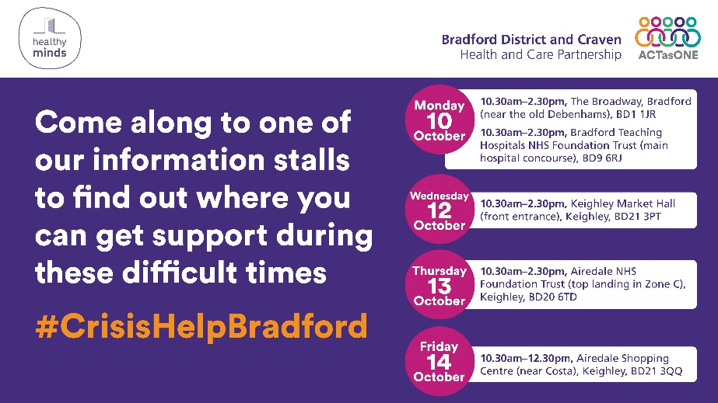
It’s important that you look after your #MentalHealth visit information stalls taking place in the district and see what support you can access for your mental health and cost of living. Info to help w/ your emotional wellbeing, visit www.healthyminds.services #WorldMentalHealthDay  ALT: Looking after your mental wellbeing during difficult times #CrisisHelpBradford Information stalls will be taking place on Monday 10 October at Broadway from 10.30am to 2.30pm, Monday 10 October at Bradford Teaching Hospitals NHS Foundation Trust from 10.30am to 2.30pm, Wednesday 12 October at Keighley Market Hall from 10.30am to 2.30pm, Thursday 13 October at Airedale NHS Foundation Trust from 10.30am to 2.30pm, Friday 14 October at Airedale Shopping Centre from 10.30am to 12.30pm. Stalls will provide information on looking after your mental wellbeing and where to go for support, support with the cost of living, where to go for debt and housing support, and looking after your general health | It’s important that you look after your #MentalHealth visit information stalls taking place in the district and see what support you can access for your mental health and cost of living. Info to help w/ your emotional wellbeing, visit www.healthyminds.services #WorldMentalHealthDay  ALT: Come along to one of our information stalls to find out where you can get support during these difficult times #CrisisHelpBradford Information stalls will take place on Monday 10 October at Broadway from 10.30am to 2.30pm, Monday 10 October at Bradford Teaching Hospitals NHS Foundation Trust from 10.30am to 2.30pm, Wednesday 12 October at Keighley Market Hall from 10.30am to 2.30pm, Thursday 13 October at Airedale NHS Foundation Trust from 10.30am to 2.30pm, Friday 14 October at Airedale Shopping Centre from 10.30am to 12.30pm.
Instagram
Post one | Post two
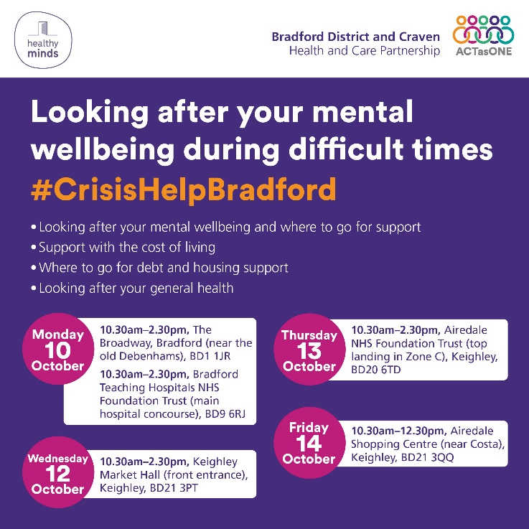 | 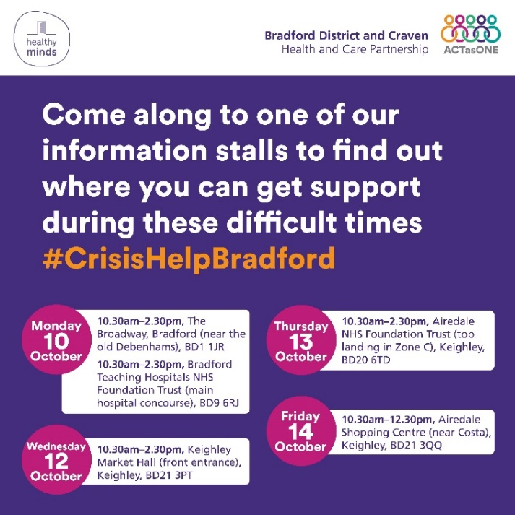
During these difficult times, it’s important that you look after your #MentalHealth  Attend one of the information stalls taking place in the district and see what support you can access for your #MentalHealth, as well as the #CostOfLiving #WorldMentalHealthDay #CrisisHelpBradford  ALT: Looking after your mental wellbeing during difficult times #CrisisHelpBradford Information stalls will be taking place on Monday 10 October at Broadway from 10.30am to 2.30pm, Monday 10 October at Bradford Teaching Hospitals NHS Foundation Trust from 10.30am to 2.30pm, Wednesday 12 October at Keighley Market Hall from 10.30am to 2.30pm, Thursday 13 October at Airedale NHS Foundation Trust from 10.30am to 2.30pm, Friday 14 October at Airedale Shopping Centre from 10.30am to 12.30pm. Stalls will provide information on looking after your mental wellbeing and where to go for support, support with the cost of living, where to go for debt and housing support, and looking after your general health | During these difficult times, it’s important that you look after your #MentalHealth  Attend one of the information stalls taking place in the district and see what support you can access for your #MentalHealth, as well as the #CostOfLiving #WorldMentalHealthDay #CrisisHelpBradford  ALT: Come along to one of our information stalls to find out where you can get support during these difficult times #CrisisHelpBradford Information stalls will take place on Monday 10 October at Broadway from 10.30am to 2.30pm, Monday 10 October at Bradford Teaching Hospitals NHS Foundation Trust from 10.30am to 2.30pm, Wednesday 12 October at Keighley Market Hall from 10.30am to 2.30pm, Thursday 13 October at Airedale NHS Foundation Trust from 10.30am to 2.30pm, Friday 14 October at Airedale Shopping Centre from 10.30am to 12.30pm.

Social media (Facebook, Twitter, and Instagram) – promoting mental wellbeing support for daytime and night across Bradford District and Craven
Facebook
Post | Image
Know what support you can access during the day and night for your #MentalWellbeing across Bradford District and Craven, this includes anyone who might be in a crisis #WorldMentalHealthDay #CrisisHelpBradford  For information and advice to help with your emotional wellbeing, visit www.healthyminds.services  ALT: Daytime and night support for anyone wanting to access support for their mental wellbeing across Bradford District and Craven, as well as support for anyone who is in a crisis. | 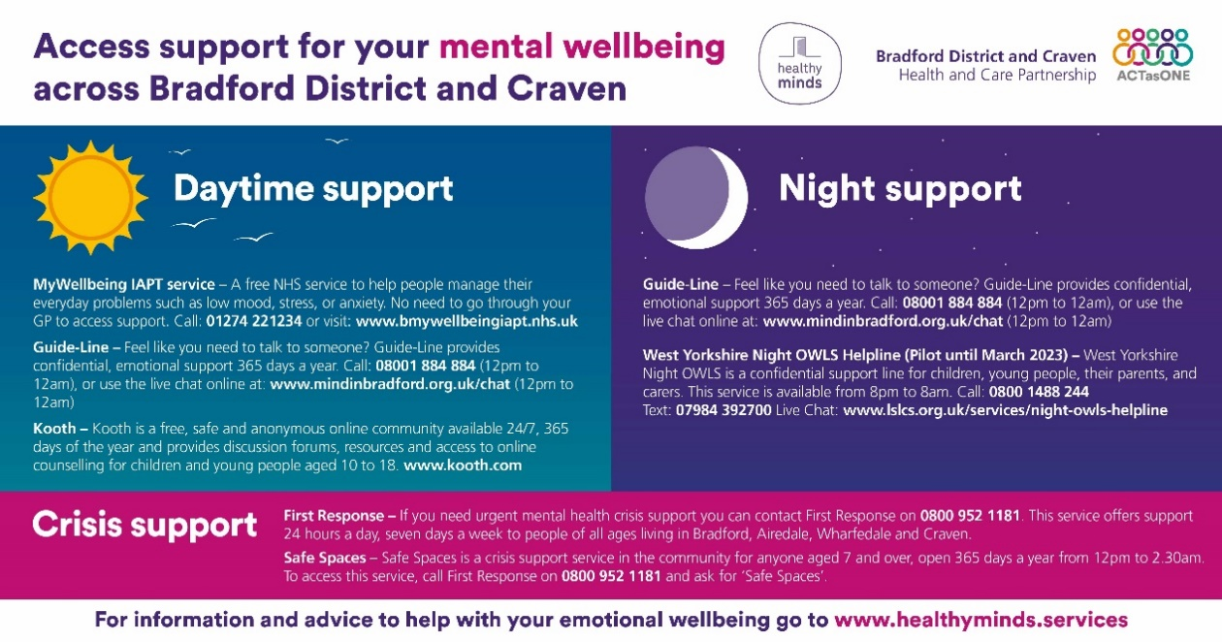

Twitter
Post | Image
Know what support you can access during the day and night for your #MentalWellbeing across Bradford District and Craven, this includes anyone who might be in a crisis #WorldMentalHealthDay #CrisisHelpBradford  Info to help w/ your emotional wellbeing, visit www.healthyminds.services  ALT: Daytime and night support for anyone wanting to access support for their mental wellbeing across Bradford District and Craven, as well as support for anyone who is in a crisis. | 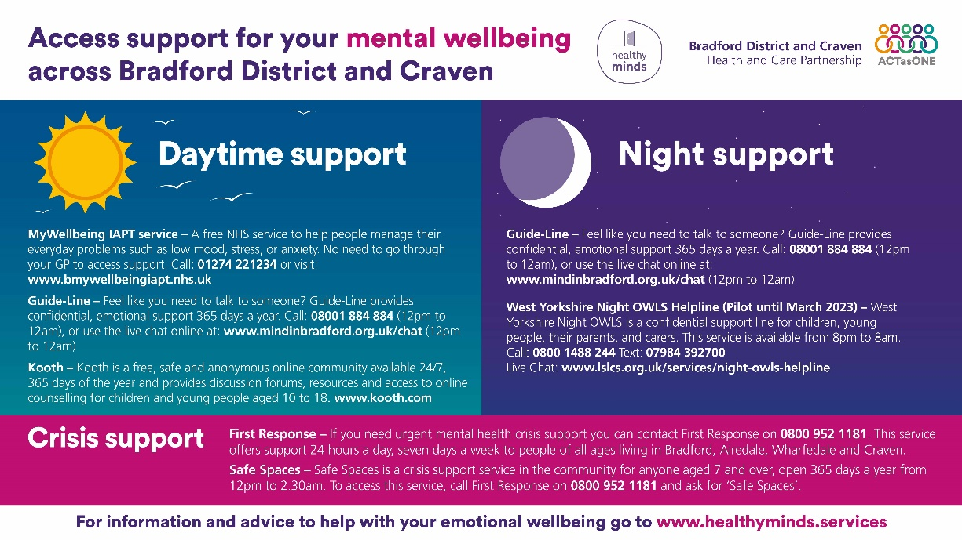

Instagram
Post | Image
Know what support you can access during the day and night for your #MentalWellbeing across Bradford District and Craven, this includes anyone who might be in a crisis #WorldMentalHealthDay #CrisisHelpBradford  For information and advice to help with your emotional wellbeing, visit www.healthyminds.services  ALT: Daytime and night support for anyone wanting to access support for their mental wellbeing across Bradford District and Craven, as well as support for anyone who is in a crisis. | 