**Parkinson’s UK reopens its Physical Activity Grants programme for 2025**

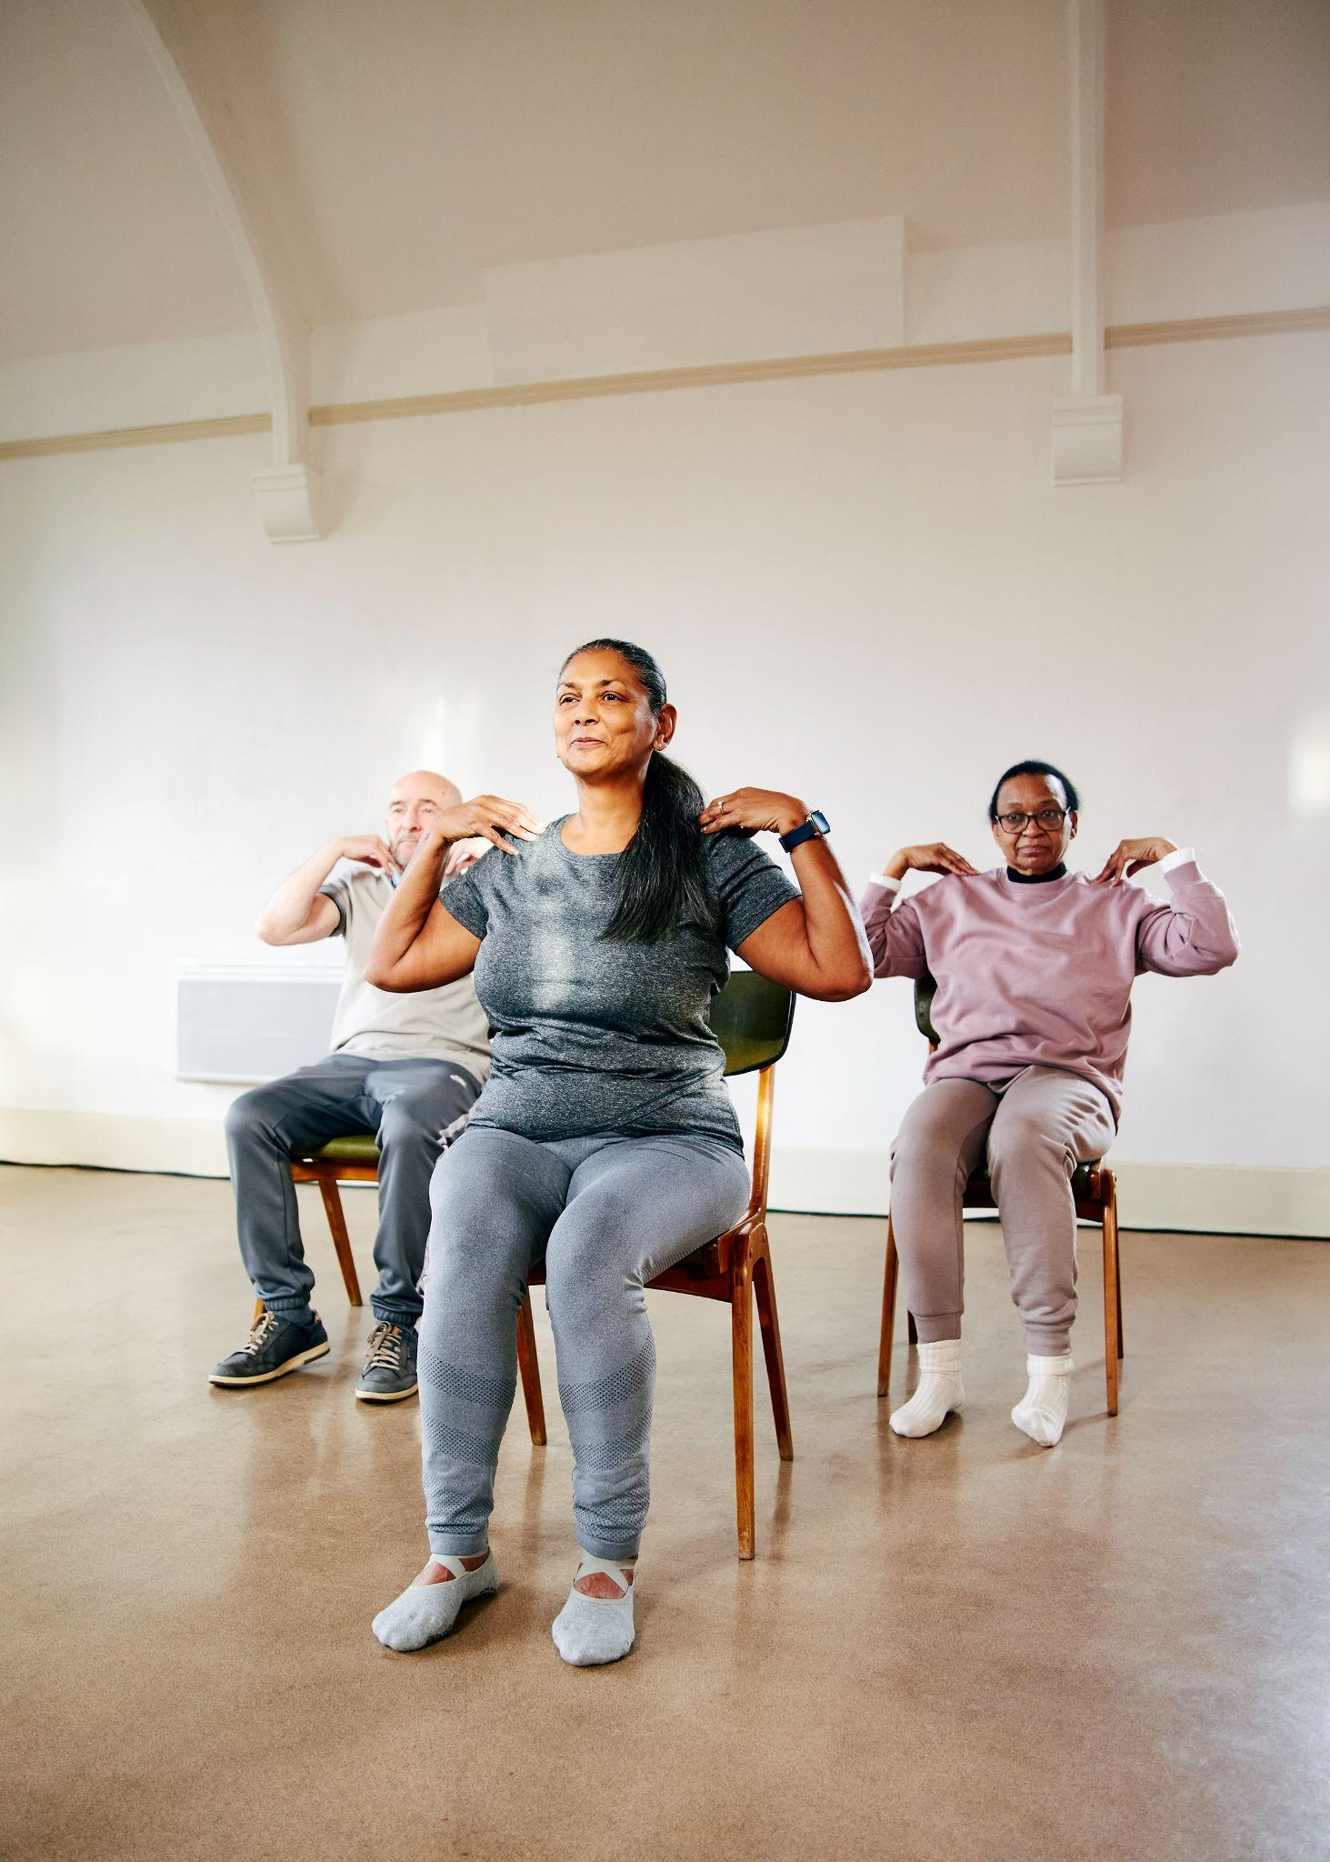

**Grants of up to £3,000 will be available for local groups, exercise coaches**

**and activity providers**

Parkinson’s UK’s Physical Activity Grants programme is open again for the fifth successive year.

Parkinson’s UK first launched its physical activity grants in 2021 and since then the programme has delivered almost £700,000 in funding for activities across the UK over the past four years.

The funds have directly helped over 200 activity providers and exercise professionals to deliver classes and active projects for people living with Parkinson’s, many of them for free.

**The** [**Physical Activity Grants programme**](https://www.parkinsons.org.uk/information-and-support/grants-physical-activity-providers) **reopened in March 2025 and is offering grants of up to £3,000.**

Applications can be made by any local community groups and clubs, exercise coaches, activity providers and physios who have a connection to the Parkinson’s community. Classes and activities can range from walking football and dance to table tennis and seated yoga, among many others.

Being active can be one of the best ways for people with Parkinson’s to manage their condition and can have many positives, including:

* Better balance and coordination
* Reduced risk of freezing and falls
* Better cardiovascular health
* Better energy levels and improved sleep patterns
* Improved strength
* Reduced anxiety

**Yanar Alkayat from** [**Yanar Mind and Movement**](https://www.mindandmovement.uk/)delivers chair yoga classes for people living with Parkinson’s in East London. She received more than £2,000 from the Physical Activity Grants programme in 2024. Speaking about the grant and the impact of funding for physical activity providers, Yanar said:

“Physical Activity Grant funding from Parkinson’s UK has really helped me deliver more free seated yoga classes for people with Parkinson’s and other long term health conditions. The classes are also open to carers and family, giving them the opportunity to look after their wellbeing and move with others too. I hope even more people in East London will be able to join us in 2025.

“The funding has truly made a difference to my work with the Parkinson’s community. It has enabled me to expand my classes to new areas, reaching more people and providing much-needed movement sessions for free. Without this support from Parkinson’s UK, these classes simply wouldn’t have been possible. I would highly recommend applying for a Physical Activity grant.”

**Roma Hashim, Physical Activity Grants Manager at Parkinson’s UK, said:**

“Following the success of our physical activity grants in 2024, we are delighted to be offering new funding for Parkinson’s professionals, exercise coaches and local groups.

“We hope to work with even more activity providers and to create new national partnerships in the coming months, as we help more people enjoy an active lifestyle with the condition.

“The grants programme continues to grow year-on-year and we have seen so many success stories in that time. As the UK’s leading charity for people living with Parkinson’s we can offer expert advice, support and training for exercise professionals, physios and activity providers who want to deliver more sessions for people living with the condition.”

**For more information about the Physical Activity Grants programme, contact** [**physicalactivity@parkinsons.org.uk**](mailto:physicalactivity@parkinsons.org.uk) **or visit** [**www.parkinsons.org.uk/information-and-support/grants-physical-activity-providers**](https://www.parkinsons.org.uk/information-and-support/grants-physical-activity-providers)

**Media enquiries**

For more information please contact: Claudia Christie, Senior Media & PR Officer, Parkinson’s UK, [cchristie@parkinsons.org.uk](mailto:cchristie@parkinsons.org.uk)

**Note to editors**

**About Parkinson’s and Parkinson’s UK**

Parkinson's is a complex brain condition that gets worse over time. It’s the fastest growing neurological condition in the world, affecting 153,000 people in the UK. It has more than 40 symptoms, from tremor and pain to anxiety, and there is currently no cure.

Parkinson’s UK is the charity that’s here to support every Parkinson’s journey, every step of the way. Wherever you’re from, whatever you need. From searching for a cure and campaigning for better health and care, to funding research into groundbreaking new treatments and running life-changing support services. It’s all driven by one mission: improving life with Parkinson’s.

[See more facts and statistics on the Parkinson’s UK website](https://www.parkinsons.org.uk/about-us/reporting-parkinsons-information-journalists).

For information and support, you can visit [parkinsons.org.uk](http://www.parkinsons.org.uk) or call the free, confidential helpline on 0808 800 0303.