IPC Quality Workshop – Part 3
Wednesday 7th July (13:30 – 16:00)
Attendance – 55 Providers

Time on Zoom Recording | Activity | Lead | Notes
0:00 – 4:20 | Introductions | Jo Martin | - QW Full Zoom Recording  - Presentation Slides  - IPC/CQC focused Quality Workshop facilitated by BCA in Partnership with Brightening Minds.
4:20 – 5:00 | Slido Poll (Appendix 1) | Jo Martin | - Providers were asked:  - Have you put into practice the Risk Management processes we refreshed on last session? (See appendix 1)
5:00 – 6:30 | Slido Poll (Appendix 2) - | Jo Martin | - Providers were asked:  - Have you any evidence of the Risk Management activity you undertaken to share with the CQC? (See appendix 2)
6:30 – 10:00 | Slido Poll (Appendix 3) - | Jo Martin | - Providers were asked:  - What is it you have been risk managing? (See appendix 3)
10:00 – 10:45 | Slido Poll (Appendix 4) - | Jo Martin | - Providers were asked:  - Have you taken action to start the planning/preparation for the completions of the PIR? (See appendix 4)
10:45 – 19:30 | Introduction to the BCA PIR Workbook | Louise Bestwick | - BCA have been working on a Workbook to help you to complete your PIR.  - There are 4 workbooks depending on the setting you are in. The workbook allows you to start planning and writing your answers before you have been given your PIR questions so it’s not one big stressful rush.  - The Workbook provides you with the question, questions type, KLOE relation, prompts, good + outstanding characteristics and space for you to write your answer and where the evidence can be located.  - Email admin@bradfordcareassociation for more info on this.
19:30 – 55:00 | CQC Q+A | Lorna Knowles (Inspection Manager, Care Quality Commission) | - CQC are transforming the way they assess Providers.  - Will help your understanding on how the CQC are changing the current assessment framework, why they are changing it and what the CQC want the updated framework to achieve.  - Written answer responses (Coming soon, please email admin@bradfordcareassociation.org )  - Watch the recording HERE (Recording time from 21 minutes in)
55:00 – 58:30 | Making it real for everyone:  The I and We sentences for good care and support | Jo Martin | - Really useful document explaining and exploring about getting to the heart of what’s important to people in terms of I and We statements.  - www.thinklocalactpersonal.org.uk/makingitreal
58:30 – 1:04:30 | 5 minute break |  | - 5 min break
1:04:30 – 1:11:00 | Slido Poll (Appendix 5) - | Clare Flynn | - Providers were asked:  - During the pandemic what poor IPC practice have you observed in your service that you need to continue to work on? (See appendix 5)
1:11:00 – 1:28:00 | Living with the impact of Covid 19 | Ben Oxlade-Parker (Covid 19 Support Team) | - It will be available on the Provider Zone until it on the New Altura Training Platform (find on PZ here, https://bradford.connecttosupport.org/provider-zone/  - Looking into the impact Covid 19 is going to have on us long term (especially over the next 6 months for Social Care)  - It covers the following:  - Infection, Prevention and Control updates  - Effective precaution/measures  - Personal protective equipment  - Waste management  - The Vaccination Programme  - The impact of ‘Long Covid’  - Working long term with Covid 19 in Social Care  - Access to testing  - Winter planning and another wave?  - Roadmap for Social Care  - Competency check
1:28:00 – 1:49:00 | Breakout Room Exercises | Clare Flynn | - The exercise questions come directly from the PIR request.  - Question 1 – how do you minimise the risk of infection in your service?  - Question 2 – How do you evidence this?
1:49:00 – 2:04:45 | Feedback from Breakout Rooms |  | PIR / Exercise Questions in Breakout Rooms  - Question 1 – how do you minimise the risk of infection in your service?  - Question 2 – How do you evidence this?  Breakout Room 1:  - Getting numbers of staff to complete E-Learning (evidence by proving the data + the knowledge the staff have after the training). To measure the impact on this some people ran random spot checks to make sure it was put into practice.  - Customer surveys, finding out what they need to work on and do next to make continuous improvements.  - Vaccinations being recorded (evidencing by using the Capacity Tracker)  - Social isolation + distancing within the service (evidencing by taking pictures)  - Tracking the steps, they have created at different times of the pandemic to show how they are minimising risks in their service (evidence by taking pictures of the timeline)  Breakout Room 2:  - Tracking the steps, they have done at before and during the pandemic to show how they are minimising risks in their service. Picking the most crucial steps and achievements they have done to help keep people safe (evidence by pictures, paper, electronic systems)  - Introducing new systems to show how you’re minimising these risks (evidence by Altura Training Platform)  Breakout Room 3:  - Observations in Domiciliary Care + speaking to the person that received the person and then observing the care (evidence by gathering the information received from these observations and looking for trends and patterns + using observation forms that are signed)  - Spot checks and the outcomes of the spot checks are then shared with staff leading to supervisions (evidence from all the records that are kept)  - IPC Audit and making sure that the actions are then completed in the future and continue to do so.
2:04:45 – 2:07:00 | Other resources available to you | Clare Flynn | - Resources made available to you around auditing or making sure you are caring for people well.  Resource 1  - Supporting excellence in infection prevention and control behaviours – Implementation Toolkit  - 3 different set of information to it (staff assets, organisational assets and visitor assets)  - Really current so very useful to use.  Resource 2  - National Care Forum Infection, Prevention and Control Compliance Assessment Tool  - Lots of information with lots of prompts to follow
2:07:00 - 2:11:00 | Other resources available to you – CQC Website | Clare Flynn | - If you want to build you audit directly from what the CQC are saying and what they are looking at look at the CQC Website.  - Infection, Prevention and Control in Care Homes  - Infection, Prevention and Control in Supported Living Services and Extra Care Housing
2:11:00 – 2:12:30 | Providers top 5 priorities | Clare Flynn | - When these Workshops first started providers were asked what their top 5 priorities were and what they would like to see covered in the workshops.  Providers top 5 were:  - Risk Management  - Infection, Prevention and Control  - Governance and Quality Assurance  - Restraint and Restrictive Practice  - Equality, Diversity, and Human Rights Principles in Practice  BCA and Brightening Minds have covered off a CQC focused Workshop, Risk Management and Infection, Prevention and Control so far.
2:12:30 – 2:17:00 | Slido Poll (Appendix 6) - | Clare Flynn | - Providers were asked:  - What would you like the key focuses to be for the Quality Workshops after the summer period? (See appendix 6)
2:17:00 – 2:20:00 | Slido Poll (Appendix 7) | Clare Flynn | - Provider were asked:  - How have you found the IPC Quality Workshop today?
2:20:00 | NEXT QUALITY WORKSHOP DATES | Clare Flynn | PART 4 – Wednesday 29th September (13:30 – 16:00)  PART 5 – Wednesday 17th November (13:30 – 16:00)  Agenda + Tickets to follow….

SEE APPENDIX BELOW

Appendix 1

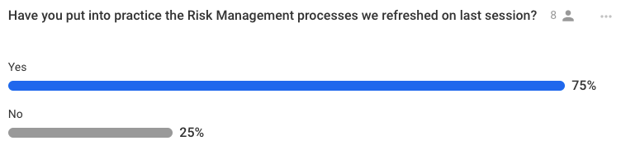

Appendix 2
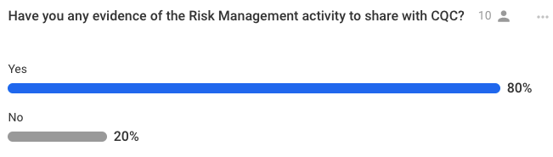

Appendix 3

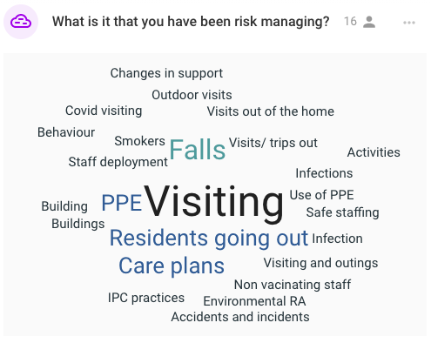

Appendix 4

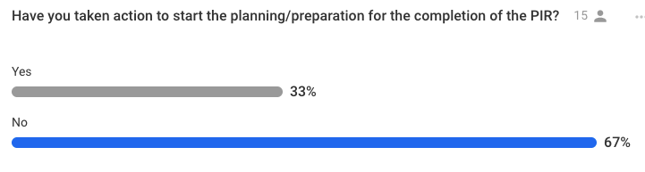

Appendix 5

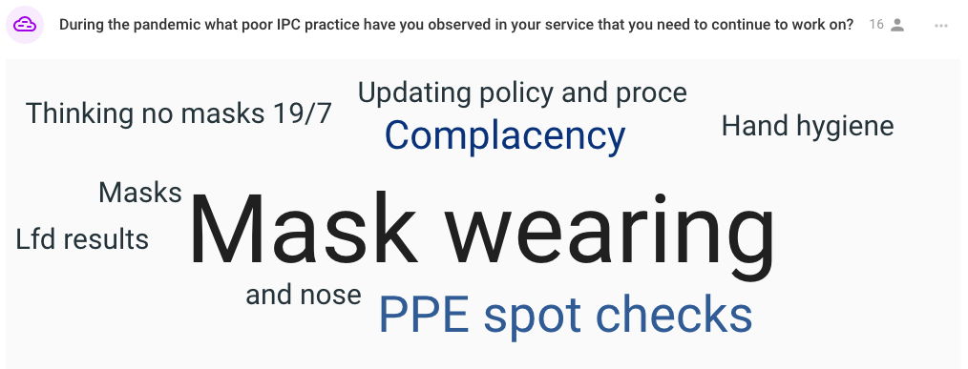

Appendix 6

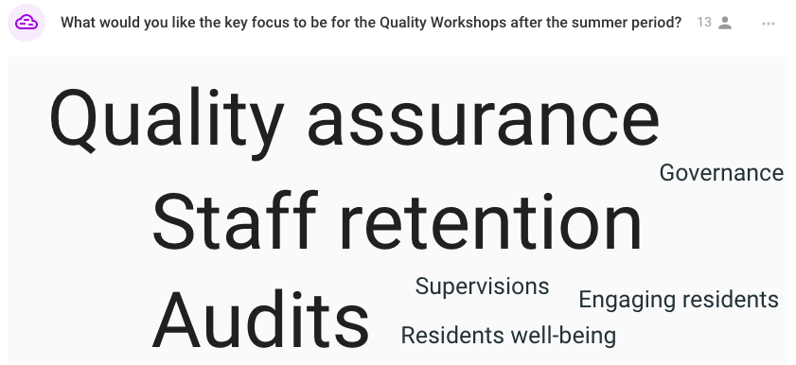

Appendix 7

