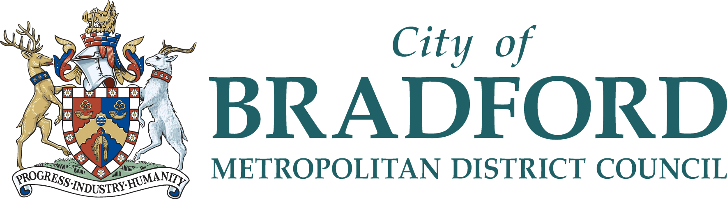
2 Day Travel Training Course
Wednesday 28th February – Thursday 29th February 2024
9am – 4:30pm
City Hall, Centenary Square, Bradford, BD1 1HX
We are delighted to invite you to attend the Level 2 Award in Skills for Teaching Independent Travel as part of our Active Travel Social Prescribing Project. The purpose of this training is to equip you with The Level 2 certificate to deliver Independent Travel Training to service users; regardless of if you are a paid member of staff or a volunteer.
The course is limited to 12 individuals, prioritising those who will be able to offer the training in particular geographical areas. If you are unsuccessful in gaining a place, we will offer another course date later in the year. Please note the course does entail a fair amount of writing (either typed or written), therefore this should be considered before a participant enters the course. Please see further information about the course here.
If you are interested in taking part on the course, please read the Travel Training Expectations document, complete the below information and email: Jaspreet.Kullar@bradford.gov.uk.

Name:
Organisation:
Job role:
Email address:

Are you able to meet the Travel Training expectations?
YES
NO

Please state if you work in any of the following areas:
Central Keighley
Manningham and/or Girlington
Bradford Moor and/or Barkerend

To be completed and returned by Wednesday 14th February 2024.
Please note due to budget constraints, refreshments and lunch will not be provided.

