Ramadan: summary of place-wide communications and engagement activity

Staff (and public) events summary

BDC HCP:
- There is potential for an Iftar at Scorex house [tbc] and to encourage staff to try a varying degree day of fasting and make a voluntary £3 donation to international charity Save the Children.

BTHFT:
- Planned ‘Fasting Fridays’ where non-Muslim colleagues will join and fast alongside their Muslim colleagues and donate £3 to Bradford Hospitals’ Charity.
- FAST packs to be handed out for those fasting and PROP packs for managers to set up dedicated departmental areas for prayer.

Airedale:
- Muslim chaplain visiting wards to speak to staff.
- 20 March: Information stand and mini fast packs handed out.
- Working with the restaurant to provide ‘snack box’ cold meals for patients who need to eat during the night (as they are fasting during the day).

BDCT:
- Sponsored event at Lynfield Mount for colleagues [date tbc].

Other key events across Bradford to make colleagues aware:
- 5 April, Kala Sangam, Arts Iftar - https://www.eventbrite.co.uk/e/arts-iftar-tickets-518947886097

Internal communications

All our organisations across place are planning varying internal comms messages to staff which will include a rich mix of engaging content covering:

- Blogs from staff. For example from Zahra Niazi, strategic equality, diversity and inclusion lead at Bradford council
- Allyship staff profiles
- Ramadan ally badge wearing
- General sharing of educational information to colleagues about Ramadan and to be respectful and sensitive of people’s needs
- Asking staff to share photos of participation
- Videos from staff including special Ramadan poem
- Encouraging non-Muslim staff to participate in a day of fasting and donate to designated charity
Generic internal comms neutral Ramadan explainer for use

Ramadan is the ninth month of the Islamic calendar. Fasting during the month of Ramadan is one of the five pillars of Islam. Muslims believe that fasting has both physical and spiritual benefits, including purifying the soul, inspiring self-reflection, and increasing empathy and good works.

God says in the Qur’an: “Ramadan is the month in which the Qur’an was revealed, as guidance for humanity…so whoever of you witnesses the month should fast it.” [2:185].

During Ramadan Muslims fast between the hours of sunrise and sunset for the entire month in gratitude to God for His final revelation. By restricting the body’s appetites during daylight hours, Muslims rejuvenate their spirituality, repair their religious conscience, and cultivate their devotion to God. Being closer to God and rejuvenating their spirituality is the most significant objective of fasting and the month of Ramadan.

It is also a time for community gatherings as families and friends come together to break their fasts and share meals.

Charity is also an essential part of Ramadan, with many Muslims donating to organisations, volunteering and feeding the poor. It is considered a way to gain blessings and purify oneself. Charity emphasises the importance of compassion, generosity, and helping those in need, highlighting the significance of this aspect of Ramadan.

At the end of the month, Eid al-Fitr is celebrated as a time of joy and thanksgiving. We would like to wish all those observing Ramadan a safe, peaceful and reflective month. If you would like to know how you can help support Muslim colleagues who are fasting during Ramadan please see this blog from Zahra Niazi, strategic equality, diversity and inclusion lead for our partnership.
Media activity

22 March: A joint press release will be issued by BDC HCP to highlight what we are doing as a
place across partner organisations and to explore potential filming opportunities with BBC Look North or ITV Calendar.

Please see press release at the end of this toolkit.

Videos for use
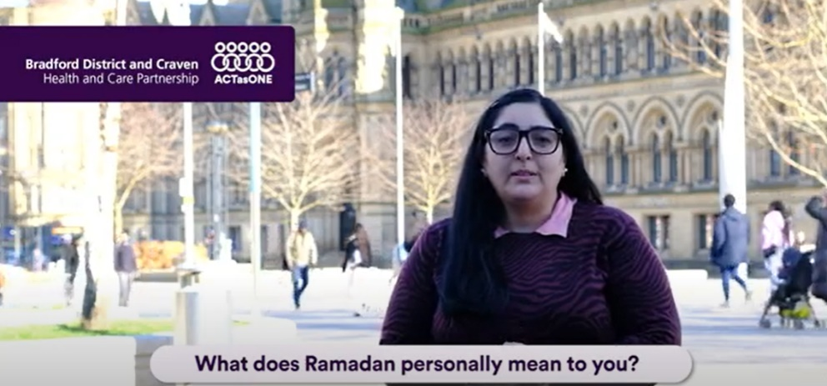
Videos are available for use for both internal and social media communications. They include:

- A Ramadan poem, read by Sasha Bhat, Bradford District and Craven Health and Care Partnership Programme Director - Healthy Minds.
- Personal reflections on Ramadan by Sasha Bhat, Bradford District and Craven Health and Care Partnership Programme Director - Healthy Minds
- Diabetes UK video about support health and care professionals can offer for people living with diabetes – to be made available once finalised.

- Google Drive to download videos (copy and paste the URL into Address Bar if issues clicking on link below): https://drive.google.com/drive/folders/1YP2Hb0jQkY2h1PJb5FsCkeTzgFGwvFDN?usp=share_link

- WeTransfer to download videos: https://we.tl/t-01lUyyjqQS

Social media content calendar

- Google Drive to download graphics (copy and paste the URL into Address Bar if issues clicking on link below): https://drive.google.com/drive/folders/1uDjXEVHEAKxlO12yy5tcpqE_1t3bl3rf?usp=share_link

- WeTransfer to download graphics: https://we.tl/t-QNxHMWEy2C

Date | Suggested copy | Graphic | ALT text
21 March | As Ramadan approaches, here are some great tips by @LadyZahraNiazi.  For colleagues working with #Muslims and for Muslim colleagues on how to prepare for the month ahead.  https://bdcpartnership.co.uk/preparing-for-ramadan-by-zahra-niazi/ | 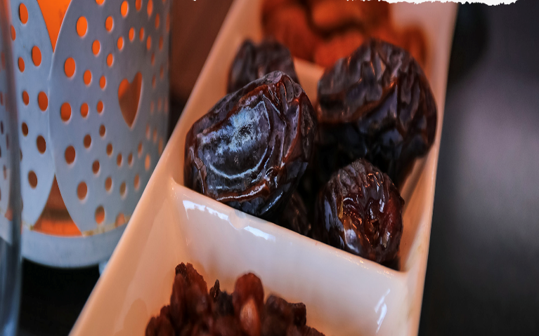 | A close up picture of dates (food).
22 March, 8pm | #Ramadan Mubarak and blessings to all those observing the holy month. |  | Text on an animated purple background. Text says: Wishing you all a blessed Ramadan Mubarak
23 March | #Ramadan health tip #1 from GP @SohailBCCG  Finding the time to get the right exercise [insert suitable emoji]  For further info and advice visit - https://britishima.org/  @BritishIMA | 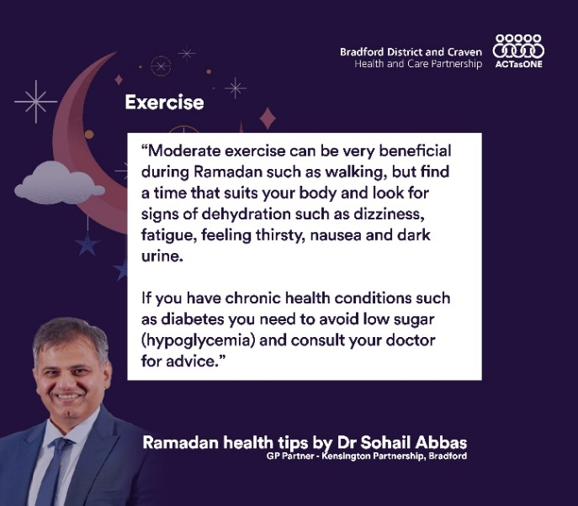 | Text on a purple background. Text says: Moderate exercise can be very beneficial during Ramadan such as walking, but find a time that suits your body and look for signs of dehydration such as dizziness, fatigue, feeling thirsty, nausea and dark urine.  If you have chronic health conditions such as diabetes you need to avoid low sugar (hypoglycaemia) and consult your doctor for advice.
24 March | #Ramadan health tip #2 from GP @SohailBCCG  Fatigue and how to manage it [insert suitable emoji]  For further info and advice visit - https://britishima.org/  @BritishIMA | 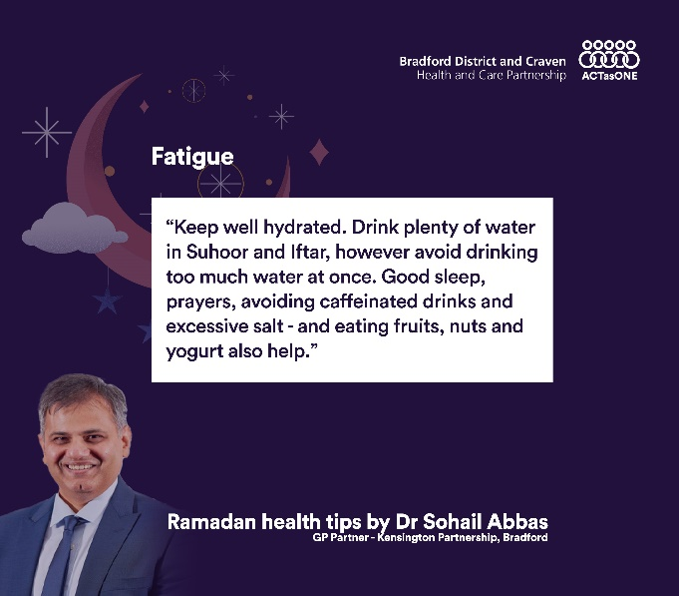 | Text on a purple background. Text says: Keep well hydrated. Drink plenty of water in Suhoor and Iftar, however avoid drinking too much water at once. Good sleep, prayers, avoiding caffeinated drinks and  excessive salt - and eating fruits, nuts and yogurt also help.
25 March | #Ramadan health tip #3 from GP @SohailBCCG  Food - what to eat and what to avoid [insert suitable emoji]  For further info and advice visit - https://britishima.org/  @BritishIMA | 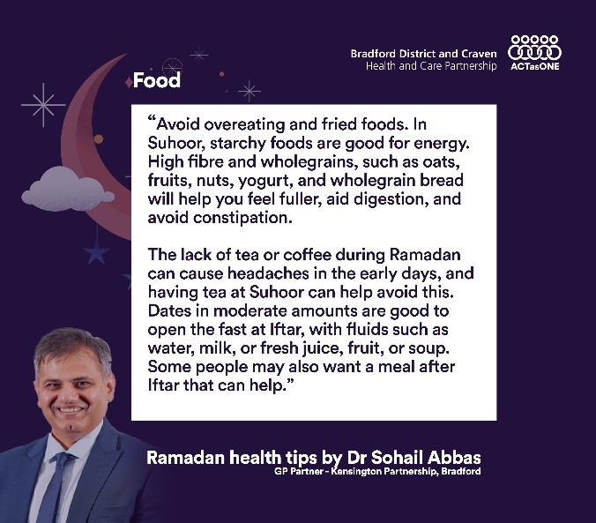 | Text on a purple background. Text says: Avoid overeating and fried foods. In Suhoor, starchy foods are good for energy. High fibre and wholegrains, such as oats, fruits, nuts, yogurt, and wholegrain bread will help you feel fuller, aid digestion, and avoid constipation.  The lack of tea or coffee during Ramadan can cause headaches in the early days, and having tea at Suhoor can help avoid this. Dates in moderate amounts are good to open the fast at Iftar, with fluids such as water, milk, or fresh juice, fruit, or soup. Some people may also want a meal after Iftar that can help.
26 March | #Ramadan health tip #4 from GP @SohailBCCG  Mind, spirituality and wellbeing [insert suitable emoji]  For further info and advice visit - https://britishima.org/  @BritishIMA | 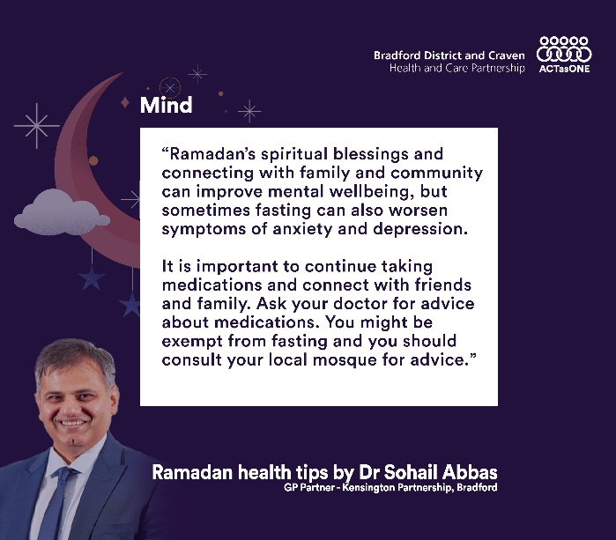 | Text on a purple background. Text says: Ramadan’s spiritual blessings and connecting with family and community can improve mental wellbeing, but sometimes fasting can also worsen symptoms of anxiety and depression.  It is important to continue taking medications and connect with friends and family. Ask your doctor for advice about medications. You might be exempt from fasting and you should consult your local mosque for advice.
27 March | #Ramadan health tip #5 from GP @SohailBCCG  Dealing with chronic illness such as diabetes  For further info and advice visit - https://britishima.org/  @BritishIMA | 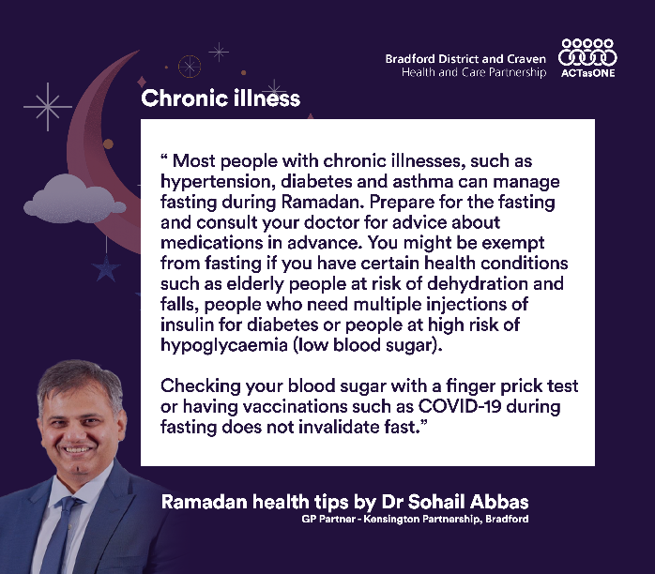 | Text on a purple background. Text says: Most people with chronic illnesses, such as hypertension, diabetes and asthma can manage fasting during Ramadan. Prepare for the fasting and consult your doctor for advice about medications in advance. You might be exempt from fasting if you have certain health conditions such as elderly people at risk of dehydration and falls, people who need multiple injections of insulin for diabetes or people at high risk of hypoglycaemia (low blood sugar).  Checking your blood sugar with a finger prick test or having vaccinations such as COVID-19 during fasting does not invalidate fast.
28 March | #Ramadan health tip #6 from GP @SohailBCCG  Sleep and getting the rest you need [insert suitable emoji]  For further info and advice visit - https://britishima.org/  @BritishIMA | 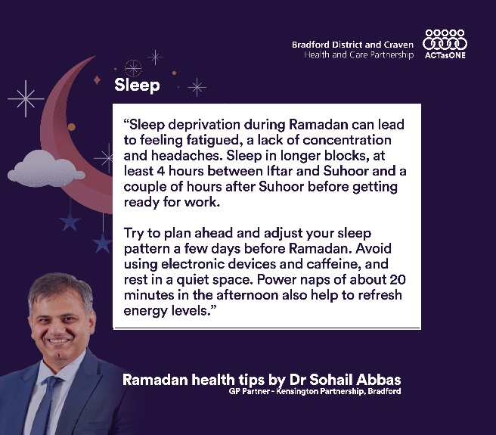 | Text on a purple background. Text says: Sleep deprivation during Ramadan can lead to feeling fatigued, a lack of concentration and headaches. Sleep in longer blocks, at least 4 hours between Iftar and Suhoor and a couple of hours after Suhoor before getting ready for work.  Try to plan ahead and adjust your sleep pattern a few days before Ramadan. Avoid using electronic devices and caffeine, and rest in a quiet space. Power naps of about 20 minutes in the afternoon also help to refresh energy levels.
21 April, 8pm | #EidMubarak to everyone celebrating Eid Al-Fitr!  Enjoy breaking your fast with friends and family as Ramadan draws to a close with the sighting of the new moon. |  | Text on an animated purple background. Eid Mubarak to everyone celebrating Eid Al-Fitr!

PRESS RELEASE (for awareness only. To be issued by BDC HCP on 21 March)

Health and care partnership recognises the month of Ramadan

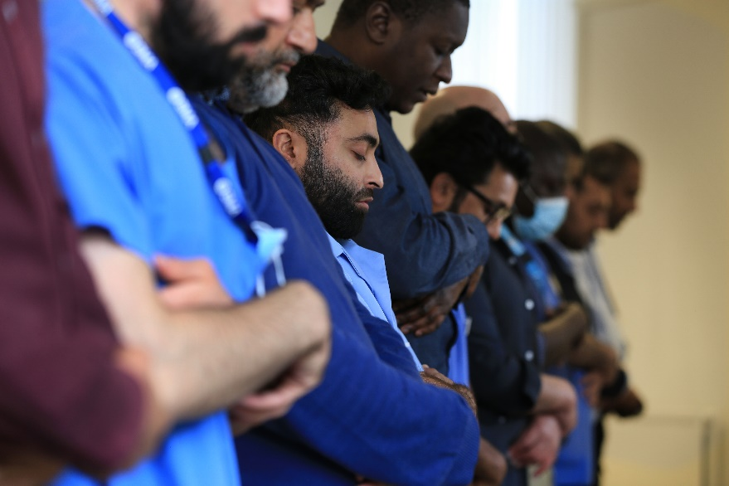
Thousands of people working across the Bradford District and Craven Health and Care Partnership are about to begin fasting to mark the Muslim holy month of Ramadan.

To mark the occasion Bradford District and Craven Health and Care Partnership - made up of local NHS organisations, local councils, independent care organisations and the voluntary and community sector - is showing its support for staff fasting during the holy month of Ramadan and encouraging non-Muslims to also participate in fasting and raise money for charity.

Across the partnership organisations are gearing up for the month by showing support for their colleagues. At Bradford Teaching Hospitals NHS Foundation Trust, Fasting Fridays are planned for non-Muslim colleagues to take part in and experience alongside their Muslim colleagues and donate £3 to the Bradford Hospitals’ Charity. Fast packs will also be handed out for those fasting containing cool bags, dates, water bottle, disposable prayer mat and prayer timetable – all packaged in a handy drawstring bag.

For non-Muslim colleagues who wish to help their Muslim team members during the Holy Month they can also become a ‘Ramadan Ally’ and receive a ‘PROP Pack’ containing items to facilitate a pop-up prayer facility, helping wards run smoothly during the Holy Month.

Similar initiatives are taking place at Airedale NHS Foundation Trust and Bradford District Care NHS Foundation Trust, which also includes opportunities for people to make voluntary donations to the respective charities for the two NHS trusts. Chaplaincy teams, including at Airedale Hospital, will also be visiting wards to speak to staff and patients to provide advice on the best way to support people observing Ramadan. Other partners will be sharing tips on how people can help those who are fasting, for example, by changing meeting times or understanding that some Muslims may not be fasting.

Professor Mel Pickup, place lead for Bradford District and Craven Health and Care Partnership, said: “During the Holy Month of Ramadan our Muslim colleagues enrich the atmosphere with their discipline, resilience and diversity, so I’m delighted to show my support for them by joining in Fasting Fridays.

“I also want to thank those colleagues for continuing to care for our local communities while fasting, and I hope that the support we will be offering during the Holy Month is a welcome gesture to bring our local partners together for a blessed Ramadan.”

Sasha Bhat, programme director for healthy minds at Bradford District and Craven Health and Care Partnership, said: “Ramadan for me is an opportunity to fill one of the core elements of my faith which is the fasting but also for me personally it’s a time for reflection and it’s a time to spend quality time with my maker. Through the acts of worship, fasting and prayer I feel really connected and committed to my faith and to my community.”

The partnership will be sharing health tips for people fasting on social media, please follow @ActAsOneBDC on Twitter.

ENDS

