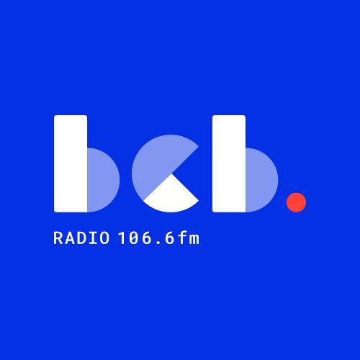

**Open Minds - BCB Radio project**

BCB, the community radio station for Bradford, is re-launching the Open Minds project to raise awareness of mental health in the Bradford District.

BCB is looking to recruit a team of people with lived experience of managingtheir mental health to produce a series of radio programmes for broadcast on BCB 106.6fm. The volunteers will be trained in radio production and presentation skills. They will then be supported to produce a series of radio programmes, highlighting lived experiences of mental health as well as the support available across the Bradford District. The programmes will aim to raise awareness of and reduce the stigma around mental health, promoting positivity and well-being.

The participants, who will be mental health service users or those living with the impact of poor mental health, will have the opportunity to learn new skills, engage in a creative activity, increase social relationships, reduce isolation and as a volunteer at BCB, make an ongoing, positive contribution to a community organisation.

Over the next few weeks, BCB will be holding taster sessions for anyone interested in finding out more.

We will be running two taster sessions on **Tuesday 3rd of June: 2.00pm - 3.00pm and 5.00pm - 6.00pm** at **BCB Radio, 11 Rawson Road, Bradford BD1 3SH**. If you are interested in attending the sessions or finding out more, please contact Mary Dowson 01274 771677. [mary.dowson@bcbradio.co.uk](mailto:mary.dowson@bcbradio.co.uk) or Dipak Mistry [dipak.mistry@bcbradio.co.uk](mailto:dipak.mistry@bcbradio.co.uk)

