**Parkinson’s UK launches new physical activity grants for marginalised communities** 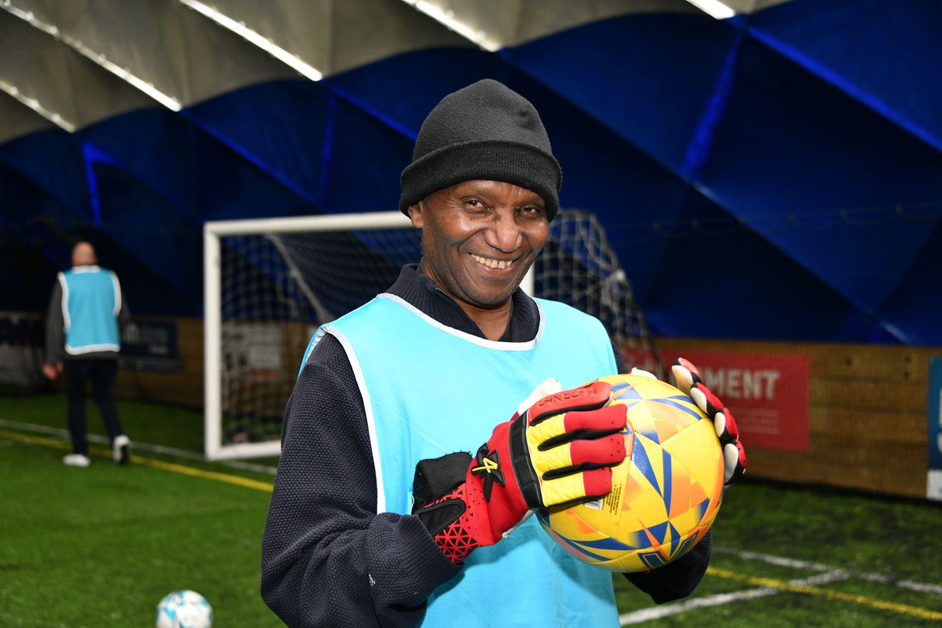

**Physical activity funding is available for people affected by Parkinson’s in marginalised communities**

Parkinson’s UK has launched a new [physical activity grants programme](https://www.parkinsons.org.uk/information-and-support/physical-activity-grants-marginalised-communities) for marginalised communities across the UK to help more people living with the condition to get active.

**The pilot grants programme will run from Monday** **2 June to Sunday 10 August 2025.** It will run in conjunction with the charity's established physical activity grants programme, which has been delivering funding of up to £3,000 for exercise professionals and local Parkinson’s groups since 2021. In that time, more than £700,000 has been delivered and more than 200 physical activity projects have benefitted from the funding.

The grants for marginalised communities aim to deliver more innovative exercise, wellbeing and physical activity projects in targeted areas across the UK. They will also offer more opportunities for those in these communities to shape the future delivery and development of the Physical Activity Grants programme.

**Funding of up to £3,000 is available for any of the following social groups affected by Parkinson’s:**

* Global majority (including all those who are previously categorised as ethnic minorities)
* People with other disabilities, be it a physical, neurodiverse or hidden disability
* People from a low socio-economic background
* People from the LGBTQIA+ community
* People from Refugee, Asylum Seeker and Migrant communities
* Women

**The following community groups and organisations that support the Parkinson’s community are also eligible to apply:**

* Community-based not for profit organisations (including charities, CICs, and constituted community groups, excluding Parkinson's UK Local groups/branches)
* Community Amateur Sports clubs (CASCs)
* Community benefit societies and Co-operatives
* Social Enterprises

Funding can be offered for exercise classes, consultation with the Parkinson's community and towards engagement events. Applicants will need to complete a brief project description and discuss their ideas with local Parkinson’s UK staff and area managers. Once they have spoken with a local Parkinson’s UK representative, applicants will be invited to complete an application form.

**Selected locations across the UK are now eligible to receive funding if they work with Parkinson’s communities from marginalised groups.**

**A full list of these locations can be found by visiting the** [**Parkinson’s UK grants for marginalised communities page**](https://www.parkinsons.org.uk/information-and-support/physical-activity-grants-marginalised-communities)**.**

**Roma Hashim, Physical Activity Grants Manager at Parkinson’s UK, said:**

“We’re really excited about launching the Physical Activity Grants for Marginalised Communities pilot programme this year. The Physical Activity Grants Programme was established to support the Parkinson’s community and the leisure industry to develop and deliver opportunities to be active at a local and regional level.

“However, we’ve since recognised that there is an increasing number of people from marginalised communities getting a Parkinson’s diagnosis who have limited access to support groups or programmes.

“Every grant aims to support people with Parkinson’s from marginalised communities to engage in physical activity, to improve their wellbeing. Their insights will also help us understand their needs and shape the future development of exercise and physical activity from Parkinson’s UK.”

**For more information about the pilot grants programme for marginalised communities, contact** [**physicalactivity@parkinsons.org.uk**](mailto:physicalactivity@parkinsons.org.uk) **or visit** [**www.parkinsons.org.uk/information-and-support/physical-activity-grants-marginalised-communities**](http://www.parkinsons.org.uk/information-and-support/physical-activity-grants-marginalised-communities)

**ENDS**

**Media enquiries**

For more information please contact: Claudia Christie, Senior Media & PR Officer, Parkinson’s UK, [cchristie@parkinsons.org.uk](mailto:cchristie@parkinsons.org.uk)

**Note to editors**

**About Parkinson’s and Parkinson’s UK**

Parkinson's is a complex brain condition that gets worse over time. It affects 153,000 people in the UK and has more than 40 symptoms, from tremor and pain to anxiety. There is currently no cure.

Parkinson’s UK is the charity that’s here to support every Parkinson’s journey, every step of the way. Wherever you’re from, whatever you need. From searching for a cure and campaigning for better health and care, to funding research into groundbreaking new treatments and running life-changing support services. It’s all driven by one mission: improving life with Parkinson’s.

[See more facts and statistics on the Parkinson’s UK website](https://www.parkinsons.org.uk/about-us/reporting-parkinsons-information-journalists).

For information and support, you can visit [parkinsons.org.uk](http://www.parkinsons.org.uk) or call the free, confidential helpline on 0808 800 0303.