May bank holidays 2023: summary of place-wide communications and engagement activity
Overview/contents

In this toolkit, you'll find resources to inform the community about looking after their health over the three May bank holidays. It includes materials about preparing for the bank holidays in advance (focusing on NHS 111, GP, and pharmacy services) as well as for the upcoming Royal College of Nursing (RCN) strikes.

Industrial action will affect Bradford Teaching Hospitals NHS Foundation Trust where RCN members will strike from 20:00 BST on 30 April to 20:00 on 2 May.

- Events summary
- Media activity/press release
- Social media content

1. Staff (and public) events summary

30 April until 2 May – Nurse strike action at Bradford Teaching Hospitals NHSFT (20:00 BST on 30 April to 20:00 on 2 May)
1 May – bank holiday
8 May – bank holiday (Coronation)
29 May – bank holiday

2. Media activity

[21 April 2023] BDC HCP will issue a press release (below) to local media.

Adapt as required

PRESS RELEASE

Local NHS urges people to prepare for May bank holidays
People are being asked to check their medication supplies and to visit NHS 111 online first for health advice over what is expected to be a busy period for NHS services during the first of three May bank holidays (1 May) and nurse strike action (30 April – 2 May).
The call comes from Bradford District and Craven Health and Care Partnership - made up of local NHS organisations, local councils, independent care organisations and the voluntary and community sector – that serves a population of around 650,000 people.
The nurse strike action will impact NHS services across the district during the 48-hour walkout. Royal College of Nursing members at Bradford Teaching Hospitals NHS Foundation Trust will be taking part in the industrial action.
Helen Farmer, Director for Access to Care at Bradford District and Craven Health and Care Partnership, said: “As the first May bank holiday approaches, we’re asking everyone in the area to ensure they’re prepared for their medical needs.

“We want you to stay happy, healthy at home and by using services such as NHS 111 online – as well as getting your COVID-19 and flu vaccinations, keeping active, and having a well-stocked medicine cabinet at home – help avoid a visit to your local A&E.

“The nurses’ strike at Bradford will have a significant impact on local NHS services and mean that your wait time in A&E will be much longer than usual if you do not have a life or limb threatening emergency. It will be quicker visiting www.111.nhs.uk, calling 111 or contacting your local GP or pharmacist.

“Remember to order in advance any repeat prescriptions you may need to last over the bank holidays via your GP practice or using the NHS App that also allows you to change your nominated pharmacy. Some pharmacies may also be open on the bank holiday so check online to find the closest one to you.”

Health advice and information is available from NHS 111, which is free and can be accessed by phone or online. It can tell you where and how to get help for your symptoms and arrange a telephone call with a healthcare professional if appropriate. You can also use the NHS website to find an open pharmacy near you.

People are being encouraged to have a small stock of basic medicines in case needed for minor illnesses or injuries and are advised to ask local pharmacists for advice on what medicines to keep at home.
Emotional support is also available over this period through Guide-Line between 8am and 12am on 08001 884 884 or the Healthy Minds website to get help. For 24/7 urgent mental health crisis support, people should contact First Response on 08009521181.

ENDS

3. Social media content calendar
Graphics on Google Drive:

Graphics on WeTransfer:

Suggested copy | Graphic | ALT text
If you need medical advice this bank holiday, use #NHS111 online to get help for your symptoms or visit your local pharmacy.  Pharmacy opening times can be found at www.nhs.uk/service-search/pharmacy/find-a-pharmacy | 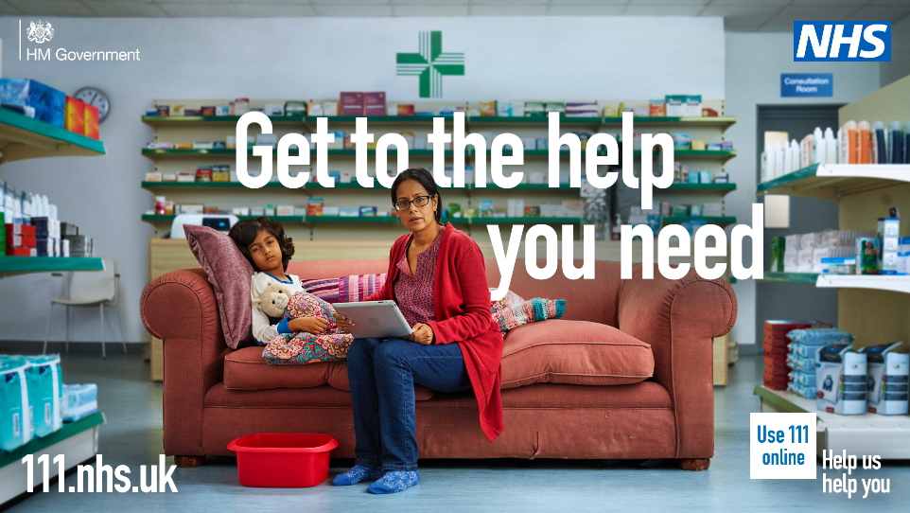 | A parent is sat on a sofa with an ill child. The parent is using a tablet. The sofa is placed in the middle of a pharmacy.  The headline text reads: "Get to the help you need"  The help us help you logo features in the bottom right of the image. The NHS logo features in the top right of the image.
Make sure you’re prepared for this bank holiday weekend.  Order your repeat prescriptions through the NHS App in advance and have a well-stocked medicine cabinet at home.  Tag Modality, Kensington Partnership and WACA in this please to amplify the message. | 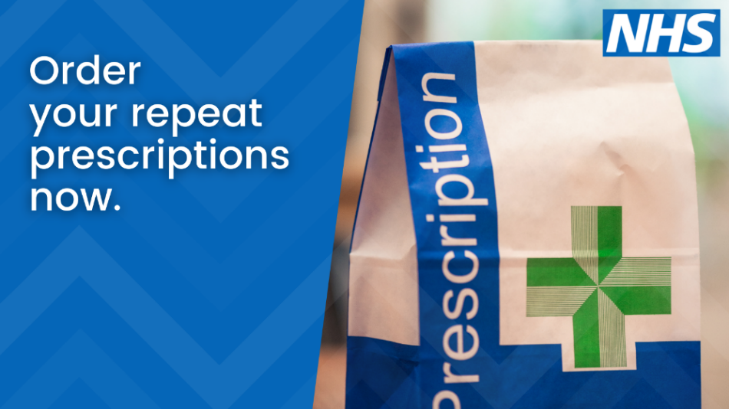 | Text on blue background. Text says: Order your repeat prescriptions now.
This bank holiday weekend, some pharmacies might have different opening hours.  Search ‘Find a pharmacy NHS’ or click below to find an open pharmacy near you. | 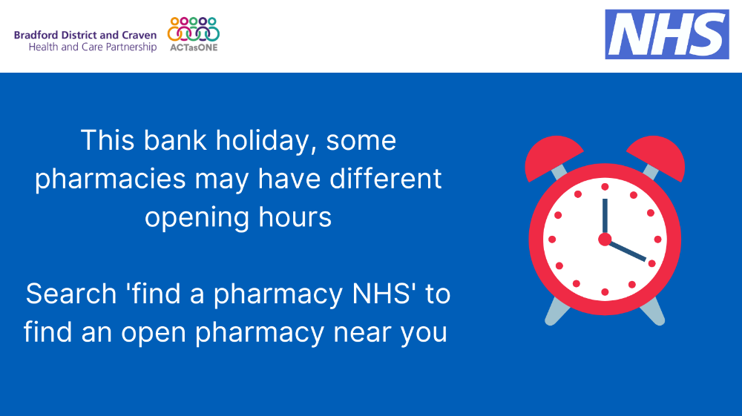 | White text on blue background. Text says: This bank holiday, some pharmacies may have different opening hours. Search ‘find a pharmacy NHS’ to find an open pharmacy near you
If you need urgent medical help, but it’s not an emergency, use NHS 111 – call 111 or go online 111.nhs.uk  This service will direct you to get the best help for your symptoms this bank holiday. | 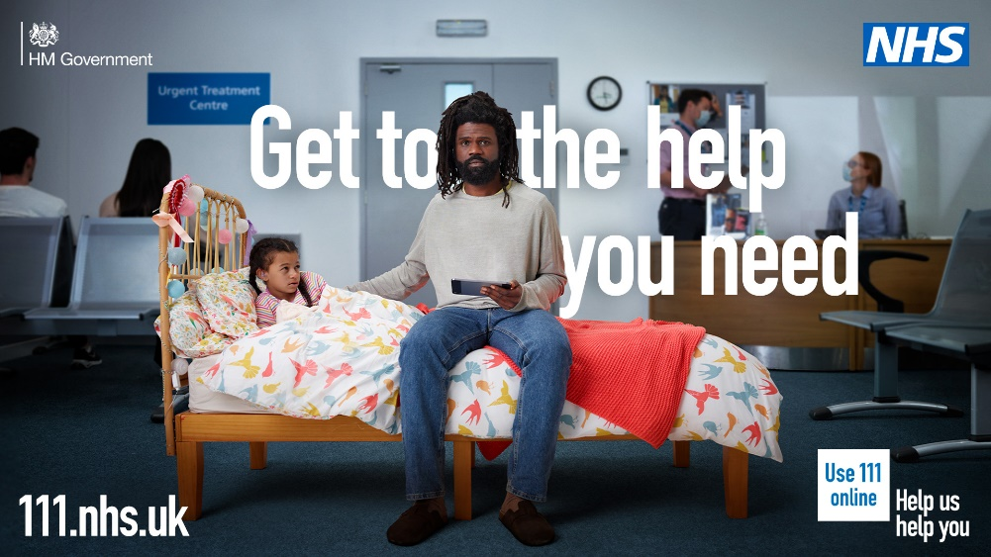 | A man sat on a bed with their child who looks unwell. He is holding a mobile phone in his hand. The bed is in the middle of an urgent treatment centre waiting room.  The headline text reads: "Get to the help you need"  The help us help you logo features in the bottom right of the image. The NHS logo features in the top right of the image.
There’s lots of mental health support available across Bradford District and Craven over the bank holiday weekend.  For information and advice, visit -www.healthyminds.services  If you need urgent mental health crisis support, contact First Response on 08009521181.  Tag Healthy Minds | 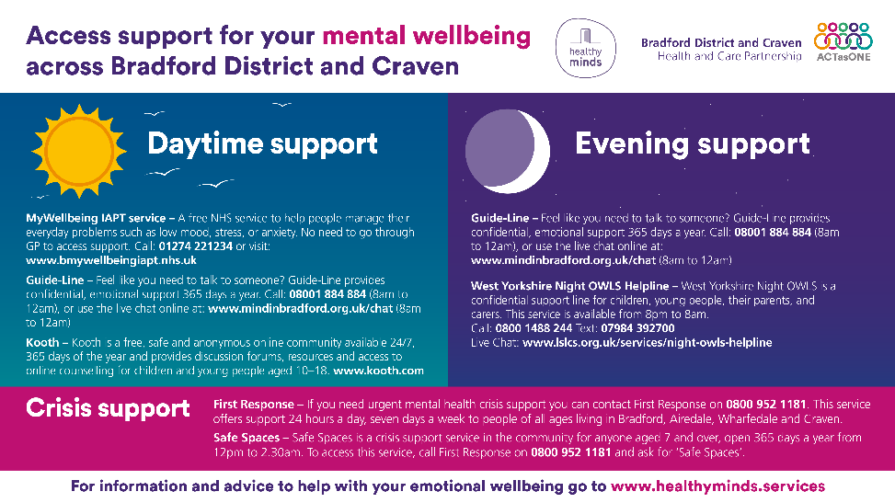 | Text says: Access support for your mental wellbeing across Bradford District and Craven.  - MyWellbeing IAPT service – a free NHS service to help people manage their everyday problems. Call 01274221234 or visit www.bmywellbeingiapt.nhs.uk  - Guide-Line – confidential emotional support 365 days a year. Call 08001884884 (8am to 12am)  - Kooth – a free safe and anonymous online community available 24/7 for children and young people www.kooth.com  - West Yorkshire Night OWLS helpline – a confidential support line for children, young people, their parents and carers available from 8pm to 8am. Call 08001488244, text 07984392700
If you need urgent medical help but it’s not an emergency this bank holiday, use NHS 111 online or call 111 to get the best help for your symptoms.  111.nhs.uk | 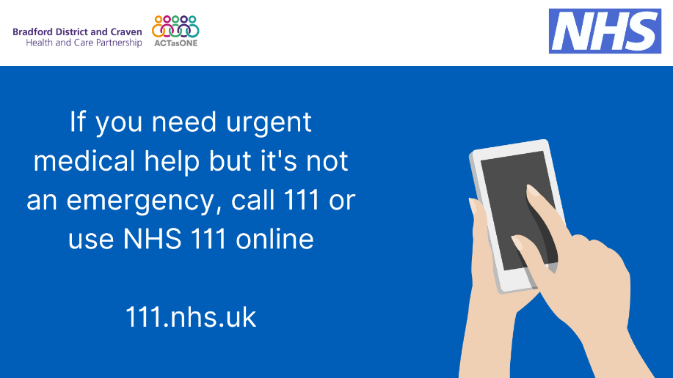 | White text on blue background. Text says: If you need urgent medical help but it’s not an emergency, call 111 or use NHS 111 online. 111.nhs.uk
With a few bank holiday weekends coming up, it’s a really good time to check that you have a well-stocked first aid kit at home or in your car. Things like plasters, antiseptic cream & painkillers can help you deal with minor accidents & injuries.  https://www.nhs.uk/common-health-questions/accidents-first-aid-and-treatments/what-should-i-keep-in-my-first-aid-kit/  Tag Modality, Kensington Partnership and WACA in this please to amplify the message. | 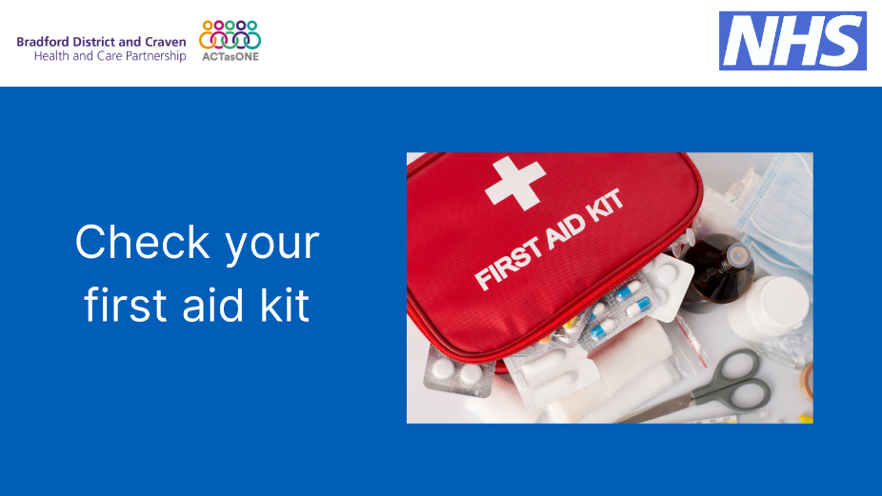 | White text on blue background. Text says: Check your first aid kit
If you need urgent dental treatment this bank holiday weekend then the NHS is here for you.  Use the NHS 111 online service.  If necessary, they’ll be able to arrange an appointment for you. | 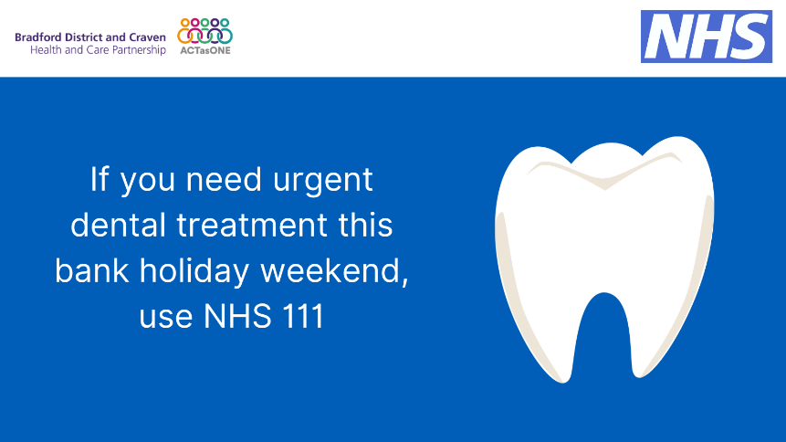 | White text on blue background. Text says: If you need urgent dental treatment this bank holiday weekend, use NHS 111.
Coronation of King Charles III [insert crown emoji]  Happy Coronation Day and thank you to everyone working this weekend.  We hope everyone in #Bradford District and #Craven enjoys the bank holiday. | 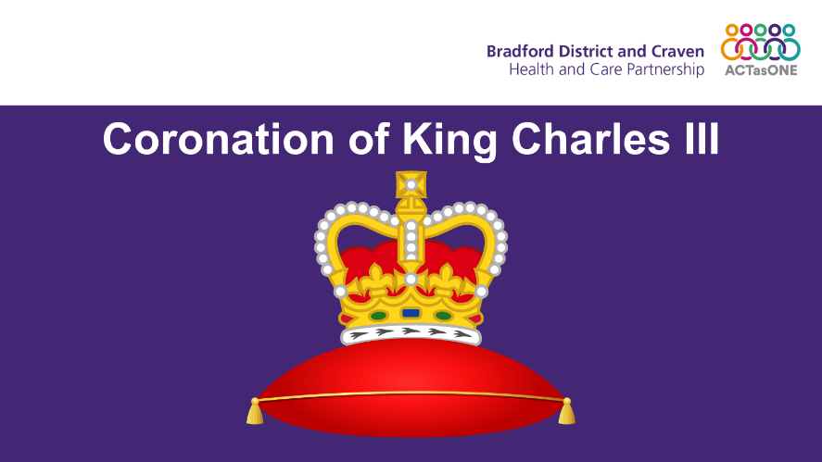 | Graphic of a royal crown on a red cushion. White text on purple background. Text says: Coronation of King Charles III.
Nurse strike action  We will contact you if we need to cancel or change the date for any pre-planned hospital appointments.  If you do not hear from us, it’s important you attend any scheduled appointments as normal. | 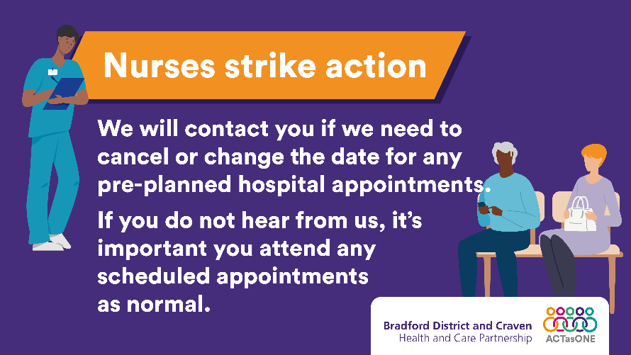 | A healthcare professional with a clipboard and two people in a waiting room. Purple background. Orange box at the top with white text saying: nurses strike action.  Text says: we will contact you if we need to cancer or change the date for any pre-planned hospital appointments. If you do not hear from us, it’s important you attend any scheduled appointments as normal.
Nurse strike action.  GP mental health and community support appointments are not affected by strike action. Please attend planned appointment. | 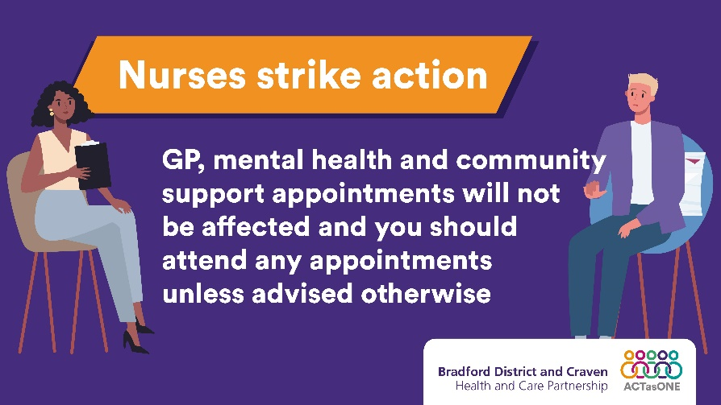 | A healthcare professional sitting opposite a patient. Purple background. Orange box at the top with white text saying: nurses strike action.  Text says: GP, mental health and community support appointment will not be affected and you should attend any appointments unless advised otherwise.
If you need medical help during the nurse strike action and bank holiday between 30 April and 2 May, please call 111 or visit 111.nhs.uk.  You should call 999 only if someone is in a life or limb threatening or very serious condition. | 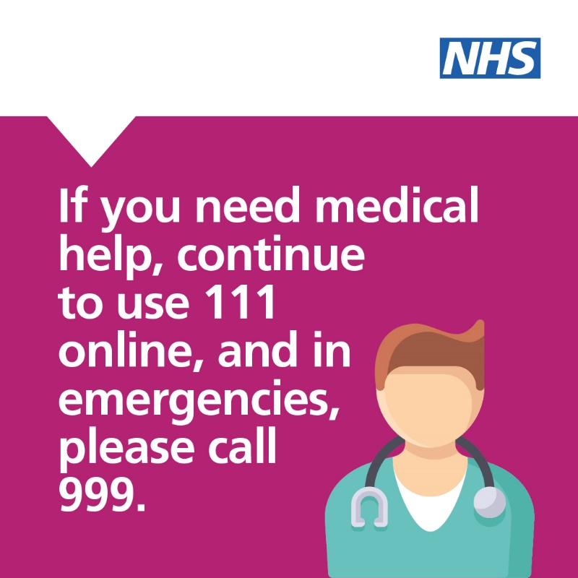 | White text on pink background. Text says: If you need medical help, continue to use 111 online, and in emergencies, please call 999.

