Press release
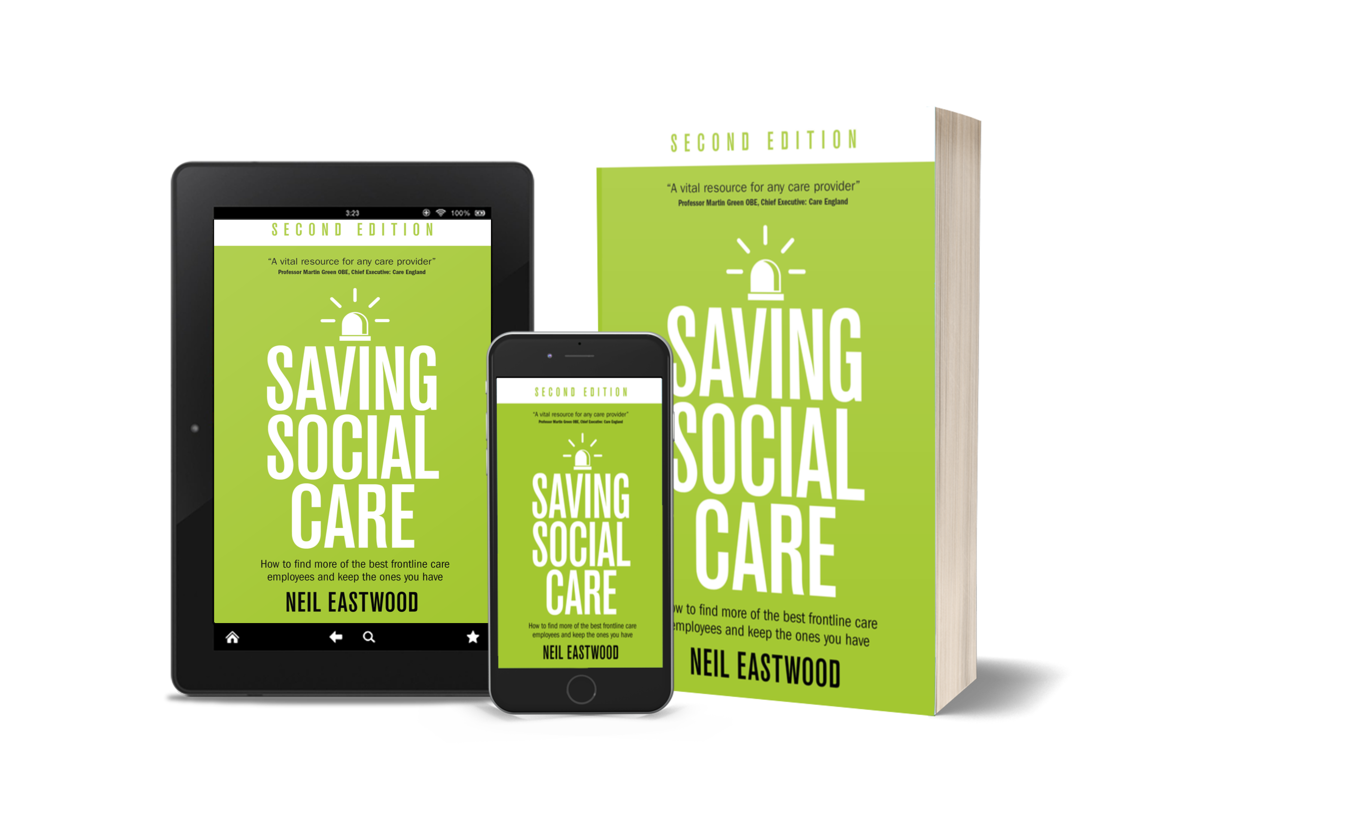
June 2023
Book Title: Saving Social Care
Available from 22 June
Book purchases:
https://www.amazon.co.uk/dp/B0C6FPSDB2/
(Kindle)
https://www.amazon.co.uk/dp/1781337748/ (paperback)
RRP: £17.99, Kindle launch price £0.99

FOR RELEASE ON THURSDAY 22nd JUNE 2023

Recruitment and retention in the social care sector receives a boost: new edition of Saving Social Care is published on Thursday 22 June
In response to the ongoing workforce crisis in the social care sector which has deepened since the pandemic, the second edition of Neil Eastwood’s seminal recruitment and retention handbook for the social care sector is launched today with a 48-hour 99p Kindle promotion on Amazon.
Over ten thousand copies of the first edition of Saving Social Care: How to find more of the best frontline care employees and keep the ones you have have been sold since its launch in 2017. The distinctive blue book has become the definitive one-stop reference for recruiters and managers on how best to recruit and retain frontline care workers.
Author Neil Eastwood says, “I have been delighted with the feedback from the 2017 first edition, but with Brexit, the pandemic and resulting labour market contraction as well as worsening staff turnover experienced by employers in recent years, I felt compelled to write a second edition. All the tips and advice still hold true, but I have brought it up to date with new research and expanded the retention section with new chapters and the latest thinking. I hope the second edition with its distinctive green cover will become as familiar a sight on the desks of recruiters as its predecessor, and will help the sector during especially challenging times.”
Professor Martin Green OBE, Chief Executive of Care England, says the book is “an essential read for anybody who is recruiting and supporting staff in a social care service. This is one of the best and most accessible books I have read on recruitment and retention. It’s a vital resource for any care provider.”
Professor Vic Rayner OBE, CEO, National Care Forum, notes “that this book has something for even the most experienced HR leader – as well as being essential reading for those looking to refresh, revise or develop their recruitment and retention strategy. It is needed now more than ever.”
Dr Jane Townson OBE, Chief Executive, Homecare Association, points to “the additional research findings and insights, particularly on the emotional importance and value of caring to those who give as well as receive care. It is excellent, evidence-based advice to enhance the workforce.”
To celebrate the launch of this new edition, the Kindle is available for just 99p on Thursday 22nd and Friday 23 June: go to https://www.amazon.co.uk/dp/B0C6FPSDB2 to secure your copy.
Neil donates all author royalties to the Care Worker’s Charity.
###
Editorial information:
Book cover and author photographs can be downloaded here:
https://www.dropbox.com/scl/fo/m7z2wksvmr60v1k9qf4td/h?dl=0&rlkey=wosvtbk4apsuen9r9nmfzfgml
Book cover photographs copyright (c) Rethink Press
Saving Social Care: How to find more of the best frontline care employees and keep the ones you have, Second Edition
by Neil Eastwood
Rethink Press
ISBN 978-1781337745
For further information contact:
Neil Eastwood 07766 496589 neil@carefriends.co.uk

