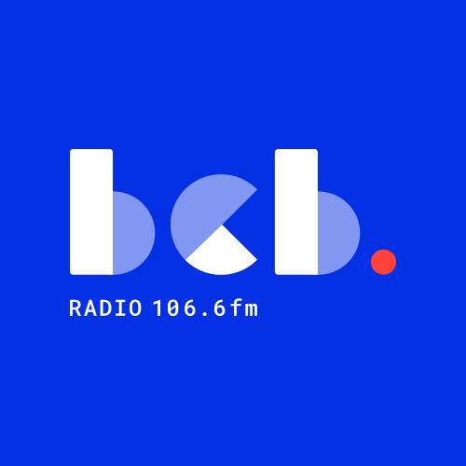

**‘Radio Times’ - BCB Radio Project**

BCB is going to be starting a brand new radio project for the over 55s. The project is called Radio Times, and will provide a weekly drop in session at BCB where people can learn radio skills, and ultimately present a new weekly afternoon programme on BCB. If you know anyone who might be interested in joining the project or finding out more about it then please let us know.

BCB is based in Bradford City Centre at 11 Rawson Road, Bradford BD1 3SH (near Oastler Market)*.*

**WE WILL BE RUNNING TWO TASTER SESSIONS ON THURSDAY THE 3RD OF JULY 2025 – 11.00am TO 1.00PM AND 5.00PM TO 7.00PM**

For more information contact us: [dipak.mistry@bcbradio.co.uk](mailto:dipak.mistry@bcbradio.co.uk) [mary.dowson@bcbradio.co.uk](mailto:mary.dowson@bcbradio.co.uk)

