20 Minute Movement Activities Weekend - Social Media Planner Page 1
Platform | Message | Image
Twitter | Join us for our FREE Activity Weekend!  Sat 13th May - Lund Park BD21 1JQ  Sun 14th May - West Park BD8 9SJ  11.30am – 4pm  Climbing tower, cricket, basketball, mountain biking, football skills and more!  No need to book  #20MinMove  www.mylivingwell.co.uk | 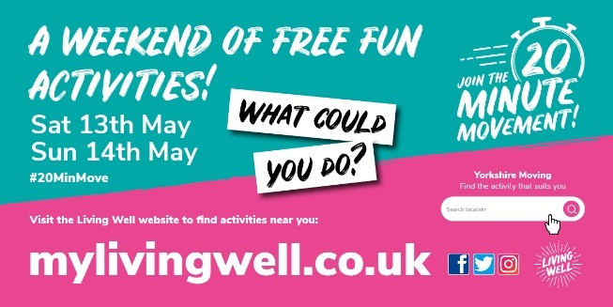
Alt text | A weekend of free fun activities! Sat 13th May and Sun 14th May. Visit the Living Well website and use the activity portal to find activities near you. What could you do? www.mylivingwell.co.uk
Facebook | Join us for our FREE Activity Weekend!  Sat 13th May - Lund Park BD21 1JQ  Sun 14th May - West Park BD8 9SJ  11.30am – 4pm. No need to book  20 minute fun activity challenges: Climbing tower, cricket, basketball, mountain biking, football skills and more!  #20MinMove  www.mylivingwell.co.uk | 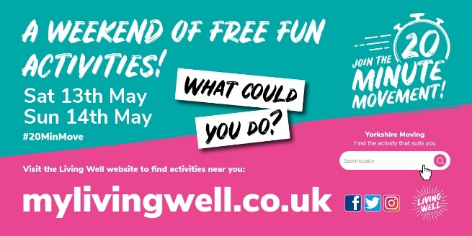
Alt text | A weekend of free fun activities! Sat 13th May and Sun 14th May. Visit the Living Well website and use the activity portal to find activities near you. What could you do? www.mylivingwell.co.uk
Instagram | Join us for our FREE Activity Weekend!  Sat 13th May - Lund Park BD21 1JQ  Sun 14th May - West Park BD8 9SJ  11.30am – 4pm. No need to book  20 minute fun activity challenges: Climbing tower, cricket, basketball, mountain biking, football skills and more!  #20MinMove  www.mylivingwell.co.uk  #20MinMove  #motivation #health #lifestyle #healthylifestyle #exercise #free #fun | 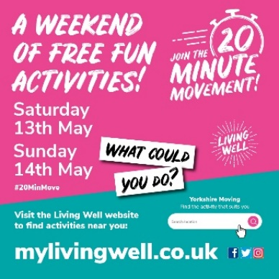
20 Minute Movement Activities Weekend - Social Media Planner Page 2
Platform | Message | Image
Twitter | FREE Activity Weekend!  Sat 13 & Sun 14 May. 10am – 3pm (9+ yrs)  Doe Park Water Activities Centre BD13 4LN  Book places here: https://www.bradford.gov.uk/sport-and-activities/outdoor-adventure/doe-park-20-minute-movement/  20 min starter sessions: Paddlesports (including kayaks, Dragon boats) & high ropes  #20MinMove  @DoeParkWAC  www.mylivingwell.co.uk
Alt text | A weekend of free fun activities! Sat 13th May and Sun 14th May. Visit the Living Well website and use the activity portal to find activities near you. What could you do? www.mylivingwell.co.uk
Facebook | FREE Activity Weekend!  Sat 13th & Sun 14th May. 10am – 3pm (9+ yrs)  @DoeParkWaterActivitiesCentre BD13 4LN  Book places here: https://www.bradford.gov.uk/sport-and-activities/outdoor-adventure/doe-park-20-minute-movement/  20 min starter sessions: Paddle sports (including kayaks, Dragon boats) and high ropes  #20MinMove  www.mylivingwell.co.uk
Alt text | A weekend of free fun activities! Sat 13th May and Sun 14th May. Visit the Living Well website and use the activity portal to find activities near you. What could you do? www.mylivingwell.co.uk
Instagram | FREE Activity Weekend!  Sat 13th & Sun 14th May. 10am – 3pm (9+ yrs)  @DoeParkWaterActivitiesCentre BD13 4LN  20 min starter sessions: Paddle sports (including kayaks, Dragon boats) and high ropes  Search for Doe Park Water Activities Centre online to book places or see the Living Well website  #20MinMove  www.mylivingwell.co.uk  #motivation #health #lifestyle #healthylifestyle #exercise #free #fun | 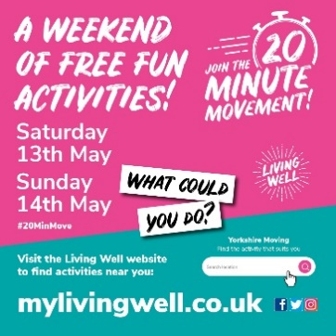
This planner shows a selection of suggested messages using some of the graphics in the activation pack.
If you would like to create your own messages, please tag us @MyLivingWell1 and use the hashtag #20MinMove so that we can like and share too!
If you add our web address, other people can learn more about the 20 Minute Movement – www.mylivingwell.co.uk

