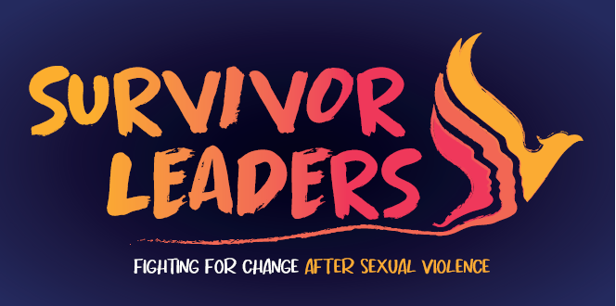

- Are you a female survivor of sexual violence living in West Yorkshire?
- Would you like to use your voice to lead the change in responses to sexual violence?
- Have you heard about survivor leadership?

West Yorkshire Survivor Leaders is a 3-year National Lottery ‘Reaching Communities’ funded project. Delivered through a working partnership of the 3 West Yorkshire Rape Crisis Centres: RASAC – Kirklees, Calderdale & Wakefield, SARSVL – Leeds, BRC&SASS Bradford. The project aims to have active Survivor Leaders groups in these areas – providing a safe space for women to come together to fight for change.
To support the development of these groups we are launching a Leadership Academy which will offer a course of free training covering leadership skills, campaigning, peer support, well-being & collective care, creating safe spaces for survivors and much more! The Leadership academy is designed to provide women with the knowledge, skills practice and support to enable them to develop local Survivor Leader groups.

Members of the project Steering Group will be hosting an online information event on:
Tuesday 18th February at 7 pm.
To register an interest in attending the information evening or to find out more about West Yorkshire Survivor Leadership Academy please email: survivorleaders@brcg.org.uk or text/leave a message on 07310077313.

We look forward to welcoming women from across West Yorkshire to share their expertise as survivors of sexual violence and have a voice in leading change!

