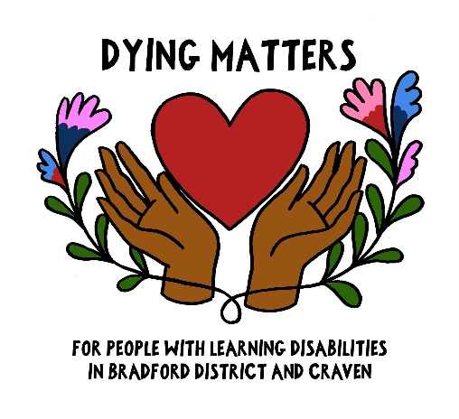
Dying Matters workshops for people with learning disabilities and those that support them

Please feel free to attend our free workshops to support improving conversations about death and dying for people with learning disabilities.
The workshops are new and so we are testing out what people need or want.
They are open to anyone with a learning disability, family members or paid carers who might be working with people with learning disabilities. They will be a safe, informal space where people can share thoughts, talk and learn from each other.
The sessions for 2023 are :
Tuesday 19th September, 10 – 12 at Marie Curie Hospice, Maudsley St, Bradford BD3 9LE
Games, refreshments, & conversations to think about ReSPECT (Planning for emergency care & treatment)
Thursday 26th October, 10am – 12 at Manorlands Hospice (Day therapy room), Keighley Rd, Oxenhope, BD22 9HJ
Games, refreshments & conversations to help support people who have been bereaved, led by Family Support Team Leader Sue Brayson.

Please contact Sandeep on Sandeep.kaur@bdct.nhs.uk or 01274 497121 to say you will be attending. We can then let you know if there are any changes to the planned time table.

