

Come & Join

***The Yorkshire Dales Strollers***

***A new Walking Group using the Dales Bus network to discover the hidden Gems of The Yorkshire Dales***

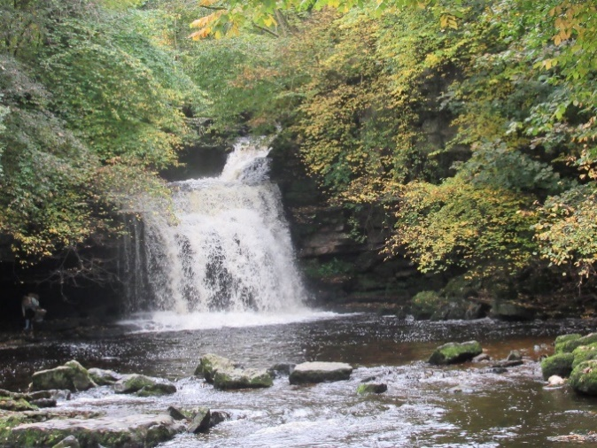

**The Last Sunday of Each Month**

**See next page for the Dales Bus information or contact us**

The walks are aimed at people who have reasonably good mobility & some of the walks will include hill climbing (up & down) and will go over uneven surfaces.

For more information phone Well Together Service on 01274 259190 or

email: [**Welltogether@bdct.nhs.uk**](mailto:Welltogether@bdct.nhs.uk)

Or visit our Website to find out more about our service

[**https://www.bdct.nhs.uk/services/well-together-service/**](https://eur02.safelinks.protection.outlook.com/?url=https%3A%2F%2Fwww.bdct.nhs.uk%2Fservices%2Fwell-together-service%2F&data=05%7C01%7CSarah.Bayles%40bdct.nhs.uk%7C952a3c683389497f288a08da494a380e%7Cf377edd1c32a465086639fc3ec794b84%7C0%7C0%7C637902880353219229%7CUnknown%7CTWFpbGZsb3d8eyJWIjoiMC4wLjAwMDAiLCJQIjoiV2luMzIiLCJBTiI6Ik1haWwiLCJXVCI6Mn0%3D%7C3000%7C%7C%7C&sdata=etmXrdExKXTmWf0rzOBhiWnxm6m%2FZgMhtUo5XMba924%3D&reserved=0)

](https://www.facebook.com/WellTogetherBDCFT/)



***Sunday April 28th***

**Linton to Grassington via Hebden**

***approx. 4 ½ miles***

**Getting there – Catch the 864 Malham Bus from**

**Bus Stop B1 on Bridge St. (opp the Interchange) @ 9.25am**

**Bus Stop L On Cheapside (opp Midland Hotel @ 9.27am**

**Bottom of Oak Lane on Keighley Rd @** **9.30am**

**Shipley Market Square @ 9.40am**

**Charlestown Baildon @ 9.45am**

**Burley In Wharfedale @ 9.58am**

**In Ilkley Transfer onto the 10.12 am 874 Buckden Bus**

**(the walk leader Muppett will be on it)**

**It’ll be a single decker York Pullman bus**

**( Don’t get on the double decker Hawes Bus!!!!!)**

We will start from the bus shelter at Linton Crossroads and walk along the road into the scenic village of Linton. From there we follow a path through several fields and follow a back lane into the hidden hamlet of Thorpe. From here we’ll then head down to the Grassington road and head through the fields down to Hebden Suspension Bridge and head up to Hebden. From here we’ll then head through the fields, passing through the wildflower meadows in the former grounds of Hebden Hospital, then head along High Lane and finish in Grassington.

**You have an option then to catch the 3.00pm 72 bus to Skipton which connects to the 3.30pm 873 bus to Ilkley and this in turn connects to a train and bus connections to Burley In Baildon, Shipley & Bradford.**

**Alternatively you can enjoy the cafés and pubs or explore the area further and catch the 4.53 pm 874 Bus that Heads back to Ilkley and connects with the 5.45, 864 bus to Bradford**

**For More details on the bus times see this link;**[dalesbus.pdf](https://www.dalesbus.org/uploads/1/1/3/9/113919127/dalesbus.pdf)