Winter Planning Quality Workshop
Wednesday 9th November 2022 (14:00 – 16:00)

Time on Zoom Recording | Activity | Lead | What the section covers + key notes
 | Introductions | Jo Martin (Opening Minds Training and Consultancy Ltd)  T: 01423 561119  M: 07788 241546  E: jo.martin@opening-minds.org.uk  Clare Flynn (Registered Manager at Brightening Lives Ltd)  M: 07444 458641  T: 01423 561119  E: clare.flynn@brighteninglives.co.uk | - QW Full Zoom Recording  - Presentation Slides  - Winter Planning focused Quality Workshop facilitated by BCA in Partnership with Brightening Minds.  - This practical session will help you to complete your Winter Plan and will also include:  - Health & Social Care current stresses and strains - The National, Regional and Local picture  - What are your concerns, risks and issues?  - Winter Resilience - Preparation & Planning
00:00 – 04:00 | CQC – The State of Health Care and Adult Social Care in England 21/22 | Jo Martin (Opening Minds Training and Consultancy Ltd) | - Looked at The CQC State of Health Care and Adult Social Care in England 21/22 and the additional winter strains:  - Additional winter strains and what we need to think about in our Business Continuity Plans:  - Impact of strike action (NHS)  - Power outages  - IT goes down  - Food shortages  - Impact of cost of living on staff  - Staff availability  - Winter weather conditions
04:00 - 18:00 | Skills for Care – State of Care Report | Rachael Ross (BCA Workforce Lead)  E: rachael.k.ross@hotmail.com | Skills for Care, State of Care Report outlined some facts and figures about workforce within the sector.  The adult social care sector is facing unprecedented challenges in workforce supply and demand. But it also represents an invaluable contribution to society and is a fundamental part of all our communities. The size and scale of the sector should not be overlooked.  Recruitment and retention are a short term and a long-term challenge for the social care sector. We still have a very diverse workforce. It is understood that the R&R challenges we face is influenced massively by pay.  Please see appendix 1 for the breakdown of facts and figures.
18:00 – 34:00 | Local Pressures | Louise Bestwick (BCA, CEO)  E: louise@bradfordcareassociation.org | The BCA created a survey around working in Social Care and asked providers to complete it. BCA share the results with the Yorkshire & Humber Region, CEOs of LA, Elected members, DAS and NHS. The reason for this meeting was to drive some change and see what can be achieved locally.  Sustainability - Fragility in Social Care  The survey results showed:  - 20% Care Homes have reduced the number of beds available  - 30% in danger of business failure within the next 6 months  - 40% Home Care Providers are at risk of handing packages back to LA  - 50% Providers are contemplating exiting the market within the next 6 months  - 80% reduction in their service provision (No. of beds / hours) without an in-year uplift  - 90% reduced ability to take on complex service user /packages  Rising Costs  - Inflationary Costs  - Staff  - Agency costs (£22 – £35 per hour for care assistant)  - Recruitment costs  - International recruitment  - Vehicle  - Fuel costs  - Maintenance costs  - Purchase costs – including zero emission  - Energy  - 500% increase in energy contracts (minimum)  - Government scheme will provide little support  - Food  - Staple goods 25%+  - Insurance  - Significant increase in premiums and reduced cover  - Interest rates  Winter Pressures  - Capacity at risk  - Demand increasing  - Impact on system  - Covid / Flu  - No Insurance for Covid admissions  - Challenges managing outbreaks  - Isolation pays  - External factors  - Energy / fuel rationing  - Industrial action  - Systems are not in place to support Social Care
34:00 – 40:00 | Slido Poll |  | We asked Providers: What do you think you need support with to sustain your business over the winter? (Please see appendix 2)
40:00 – 51:00 | Bradford Provider Handbook | Paul Hunt (Contracts & Commissioning Team)  E: paul.hunt@bradford.gov.uk  M: 07582 101643 | The Covid-19 support Team, BCA and other system partners created some Provider Handbooks/Resource packs during the Covid Pandemic that providers found very useful. It was clear that they needed updating and that the handbooks should be an all-year-round resource for providers (including all care focus challenges and not just Covid).  Work is now being done on these handbooks and there will be 2 (Home Care and Care Home). They include contact information, good practice and clear guidance at a local and national level. They will act as a live document that will be updated at a minimum of every 2 weeks.  They are still in the process of being created and finalised – Hopefully ready for the end of November. Providers will be able to explore these via the Provider Zone.  Please contact Paul Hunt for more information / if you have any recommendations of what should be included handbooks.
51:00 – 57:00 | KLOE’s | Jo Martin | Looking at the CQC Key Lines of Enquiry – what do you as a provider need to do to ensure you’re being complaint, how you will answer the CQC questions and how you’re going to evidence that you’re being compliant (See appendix 3 for KLOE’s).  You need an up-to-date Business Continuity Plan so you can evidence to CQC how you’re being compliant and help you in order to answer CQC questions to you.
57:00 - | Business Continuity Plan | Clare Flynn | BCA have divided a Business Continuity Plan Template by merging the Care Provider Alliance BCP and the Bradford Checklist that was developed last year. The BSC is currently being finalised. This draft template will help you think about what you need to include in your Business Continuity Plan to ensure you have addressed everything and figure out what you need further support with.  Use the template to develop your Business Continuity Plan. You should adapt it the template to ensure it fits for your service!  Do this by working through each section, heading, thinking about the mitigating actions and answer and filling out (by answering the mitigating actions, you will be creating your BCP).  BCA Draft Business Continuity Plan Template  During the QW, we focused on 1 key area – Severe Adverse Weather:  Please watch Zoom recording for breakdown of how to answer the Severe adverse weather section.
 | Slido Polls |  | Providers were asked – How did you find the Quality Workshop today?  Providers were asked - Are there any key area's / topics that you would like us to cover on our next workshop?

Please see appendix below:

Appendix 1

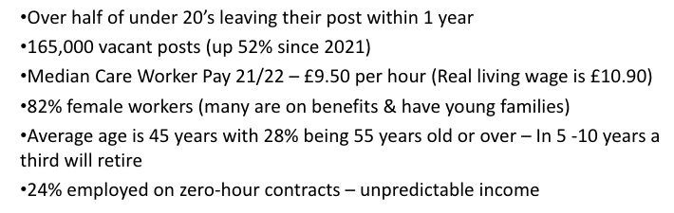

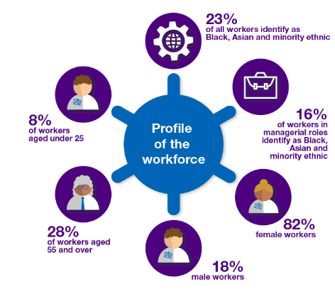
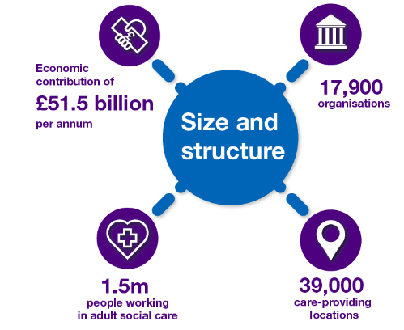

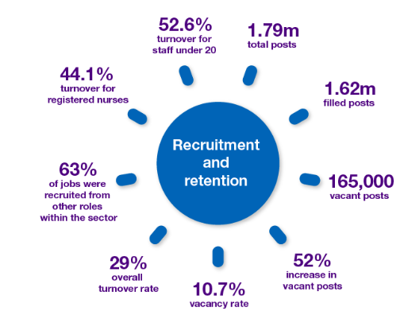
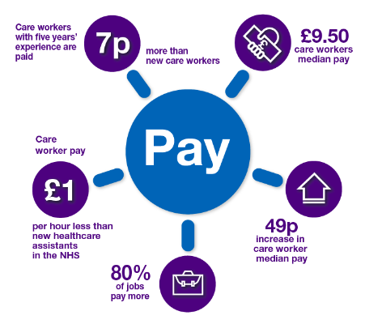

Appendix 2

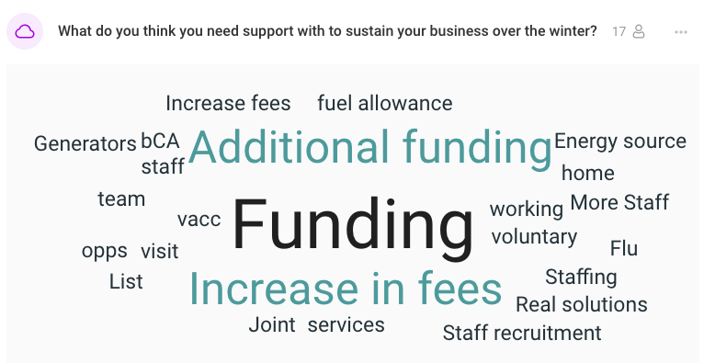

Appendix 3

