[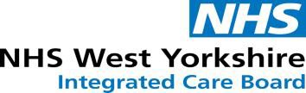](https://www.westyorkshire.icb.nhs.uk/)

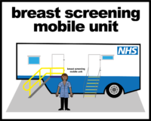 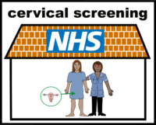 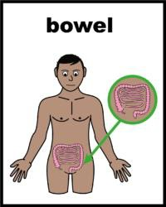

Health education & Wellbeing event

**for people with learning disabilities and neurodiversity,**

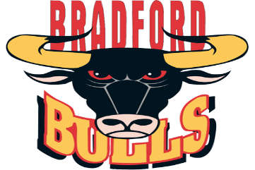**in association with Bradford People First**

17th September 2025, 10am-4pm (Talks from 10.30 am)

At Bradford Bulls, Odsal Stadium, Bradford.

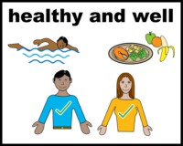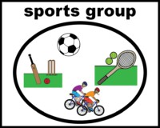

Come and find out how to keep yourself healthy - Learn about Healthy eating, Bowel, Breast and Cervical screening, Stop smoking, Dental, and getting involved in mixed ability sports!

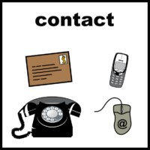

**Contact Justine Joy on 07583 100098 or**

**justine.joy@bradford.nhs.uk for more information or book on**

**via Eventbrite:** [**Health & wellbeing event for Learning Disabilities and Neurodiversity. Tickets, Wed, Sep 17, 2025 at 10:00 AM | Eventbrite**](https://www.eventbrite.com/e/health-wellbeing-event-for-learning-disabilities-and-neurodiversity-tickets-1418606001739?aff=oddtdtcreator&utm_source=email&utm_medium=sparkpost&utm_campaign=postpublish)

Everyone attending needs to book a space to get Free Lunch and drinks!

