***Information for Girlington PS children and parents – Can be shared with other community groups in Girlington***

**Dr Bike Maintenance Checks- Get your bike fixed for FREE**

**Dr Bike** is a free safety check intended to make your bike roadworthy. Our JU:MP Bicycle Mechanics will check the bike and carry out minor repairs and adjustments to enable safer riding.

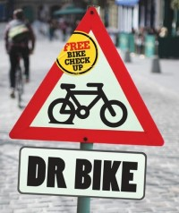***Repairs include;***

*Pumping up tyres and puncture repair*

*Replacement of minor parts, brake/gear cables, brake blocks etc (if required)*

*Unfortunately we can’t replace major parts; gear mechanisms, Brake levers, wheels etc*

The Dr Bike Workshop will take place at Girlington PS Bring bike to staff car park on Girlington Rd

**Date:** Monday May 20th 2024

**Time**: 8.30am bike drop off. Pick up 3 – 4pm

**What to do if you would like a FREE Dr Bike Check:**

1. On the Dr Bike day bring your bike to school preferably with your parent/carer, to **staff car park** & explain any problems with your bike.
2. Go to school and enjoy your day.
3. At the end of school come and collect your bike. If there is a sheet attached this will detail any recommendations about any more mechanical work that needs to be carried out by a bike shop.
4. Please note that JU:MP bike mechanics will be with the bikes until 4pm. Pick up time is between 3 – 4pm

*Dr Bike will endeavour to get through as many of the bikes on the day as possible and places will be allocated on a first come first served basis.*