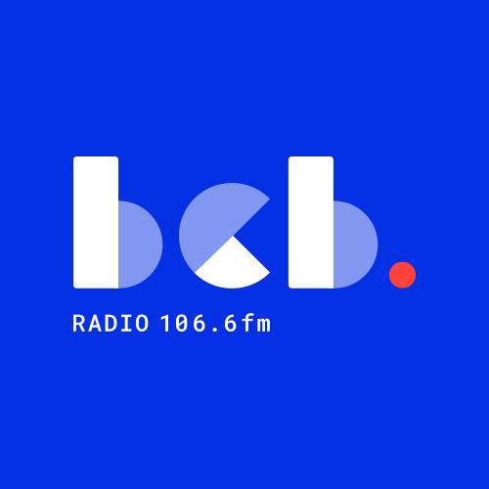

**‘Hear My Voice’ - BCB Radio Project.**

BCB Radio is Bradford’s community radio station. We train and support people from Bradford’s diverse communities in the skills needed to become volunteer radio broadcasters at BCB.

BCB is running a radio training project called **‘Hear My Voice’** for refugees and people seeking asylum in Bradford. The project will cover all the basic skills needed to make radio programmes for broadcast on BCB radio**. No previous experience is necessary!**

The main aims of the project are:

* To provide radio training for a group of 6 - 8 refugees and people seeking asylum, with the opportunity for people to contribute as volunteer broadcasters, gaining skills and experience, working alongside the BCB community in a positive, supportive, and creative environment.
* To use radio broadcasting to create greater awareness and understanding of the refugee and asylum seeker experience among the wider community in Bradford.

The radio training project will be for 8 weeks with one session 2 hours each week. Training will include interviewing skills, recording, editing, radio presenting, using the broadcast studio, programme planning. The project will create radio programmes, reports and features for broadcast on BCB.

Bus fares can be paid for people taking part.

BCB is based in Bradford City Centre at 11 Rawson Road, Bradford BD1 3SH (near Oastler Market)*.*

**WE WILL BE RUNNING TWO TASTER SESSIONS ON TUESDAY THE 1ST OF JULY 2025 – 2.00PM TO 4.00PM AND 5.00PM TO 7.00PM**

For more information contact us: [dipak.mistry@bcbradio.co.uk](mailto:dipak.mistry@bcbradio.co.uk) [mary.dowson@bcbradio.co.uk](mailto:mary.dowson@bcbradio.co.uk)

