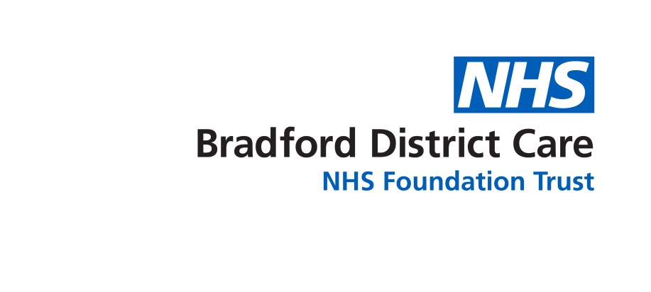

Marilou Armada – EOL facilitator for BDCT would like to offer LINK STAFF FOR PALLIATIVE CARE in care homes-BOTH RESIDENTIAL AND NURSING a 3hr-session to share good practice and discuss challenges.

What: LINK STAFF MEETING

When: 29TH JUNE 2023
9-12 or 1-4pm

Where: Rm 3.19 New Mill, Saltaire
Victoria Road, Bradford BD18 3LD

Spaces are limited-first come first served basis
To book a place, please DIRECTLY email marilou.armada@bdct.nhs.uk

