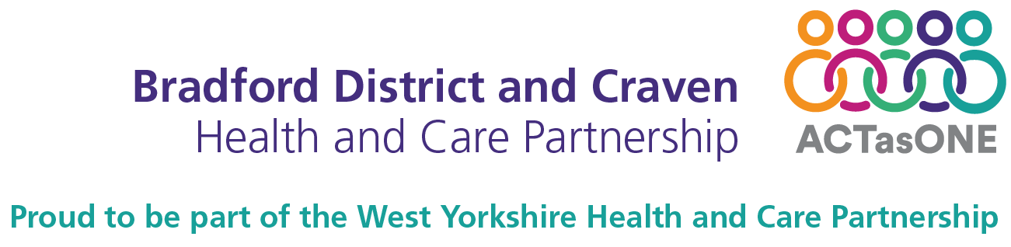

Warm homes social media campaign

Overview
Bradford District and Craven Health and Care Partnership, Bradford Council, Community Action Bradford & District (CABAD) and voluntary and community sector partners have launched a campaign which aims to support people through the cost of living crisis.
This month’s social media focus is on keeping warm and we need your help to reach everyone across Bradford district and Craven, highlighting the resources available to help them. This toolkit provides you with the information to help promote the resources we have provided.

Social media copy and images
All images are attached to the email.

Please email communications@bradford.nhs.uk if you would like us to send any of the files to you.

Channel | Post | Image | ALT text
Twitter  Facebook  Instagram | Check out these handy videos from  @IncommunitiesHA to help keep your home energy efficient this winter.  @bradfordmdc  @ActAsOneBDC  @WeAreCABAD  #COLSBradfordDistrict  https://costoflivingbradford.co.uk/energy-and-bills/ |  | Warm home tips  Check out these handy videos to help with  - Bleeding radiators  - Resetting fuse boxes  - Topping up your boiler  - Using a smart meter  #COLSBradfordDistrict

Note: further social media copy will be provided as we implement each phase of the campaign.

Website link
costoflivingbradford.co.uk

Further information for communications teams
If you need any further information, or would like to request additional assets that may be helpful for your communications, please email communications@bradford.nhs.uk

