[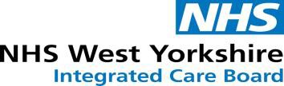](https://www.westyorkshire.icb.nhs.uk/)

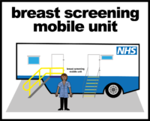 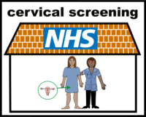 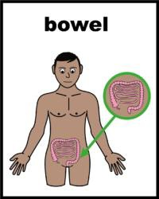

Health education & Wellbeing event

**for people with learning disabilities and neurodiversity**

**in association with Keighley & Craven People First**

10th September 2025, 10am-4pm (Talks from 10.30 am)

At Central Hall, Alice Street, Keighley, BD21 3JD

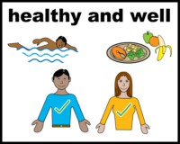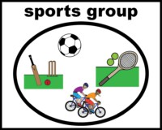

Come and find out how to keep yourself healthy - Learn about Healthy eating, Bowel, Breast and Cervical screening, Stop smoking, Dental, and getting involved in mixed ability sports!

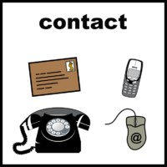

**Contact Justine Joy on 07583 100098 or**

**justine.joy@bradford.nhs.uk for more information**

**or book on via Eventbrite:**

[**https://www.eventbrite.co.uk/e/health-wellbeing-event-for-learning-disabilities-and-neurodiversity-tickets-1410384731699?aff=oddtdtcreator**](https://www.eventbrite.co.uk/e/health-wellbeing-event-for-learning-disabilities-and-neurodiversity-tickets-1410384731699?aff=oddtdtcreator)

Everyone attending needs to book a space to get Free Lunch and drinks!

