

Immedicare training timetable
September 2026
Training features:

- Training sessions for all staff working in homes with Immedicare service
- Wide range of topics covered
- Post training evaluation available for delegates to submit feedback on the sessions
- Weekly live training sessions including a certificate for all delegates who complete a full session
- 24/7 access to the full suite of recorded sessions
- Easy to access via web page
- Accessible on any device

Dates for Live Training sessions. Training times are 2 to 3pm.
- Wednesday 2nd September. Falls.
- Wednesday 9th September. Introduction to Distress Behaviours in Dementia.
- Wednesday 16th of September. Top to Toe.
- Friday 25th of September. Catheter Care.

User Guide
Here is a link to a user guide with instructions on how to access both live and recorded training sessions: User guide

Available courses

The full range of courses are available to access 24/7 via the training website in recorded form, and a range of courses are delivered live each month.
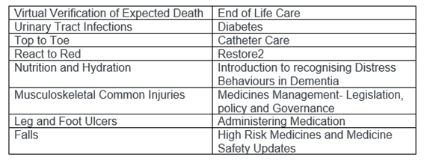
While we can confirm when a user has accessed a training session, we are unable to verify whether the full content has been listened to or viewed in its entirety. Therefore, certificates will not be issued for recorded sessions.
Accessing the training:
Visit https://involve.moodlecloud.com/ or click the link below. You must create an account, and once you have an account you can register for the courses you would like to complete.
Click here to access the training
Certificates:
While we can confirm when a user has accessed a training session, we are unable to verify whether the full content has been listened to or viewed in its entirety. Therefore, certificates will not be issued for recorded sessions.
Important information:

Immedicare training is for staff currently working in care homes with the Immedicare 24/7 clinical assessment service in place only.

Each person needs to create a training account with a valid email address and care home name prior to attending a live training session, even if you intend to watch the session in a group from a single device. At each live training session we also need you to write your name and email address in the chat box. Without an account and confirmation of attendance in the chat box, we cannot issue your certificate. Please allow up to 1 week to receive your certificate.

For any queries relating to training, please contact acunningham@immedicare.co.uk
Contact information:
email: enquiries@immedicare.co.uk
telephone: 03300883364

